Lennis Keller

October 7, 1913 – March 6, 1999

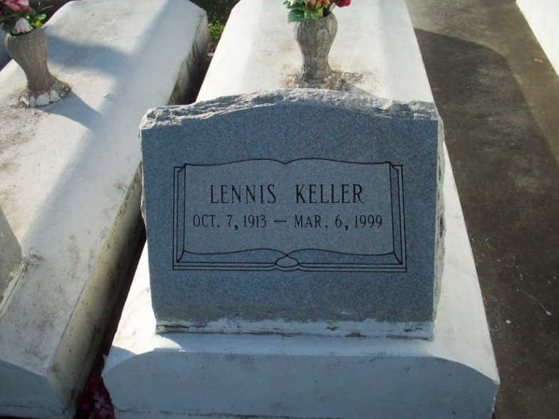

Photo by TMB

Lennis Keller, 85, a native of Vacherie and a resident of Marrero for 52 years, died March 6.  
  
He was the husband of Veronica Freeman Keller and father of Hildredge Gibson, Cathy Scott, Nellie Barthelomew, Madeline Bridgewater, Kathleen Pavadue, Jerome Keller and the late Merlin Keller. He was also the son of the late Pierre and Althea Osborne Keller and brother of Irene Lumas, Corine Love, Cecile Mundy and Joseph, Elliott, Victor and the late Landry, Armond and Rene Keller. He is also survived by 16 grandchildren and 20 great-grandchildren.  
  
Services were held March 11 at St. Joseph the Worker Catholic Church, Marrero, with interment at Our Lady of Peace Catholic Cemetery, Vacherie.  
  
L'Observateur, LaPlace, LA; March 13, 1999