Nicholas R. Keller

August 15, 1949 – December 22, 2016

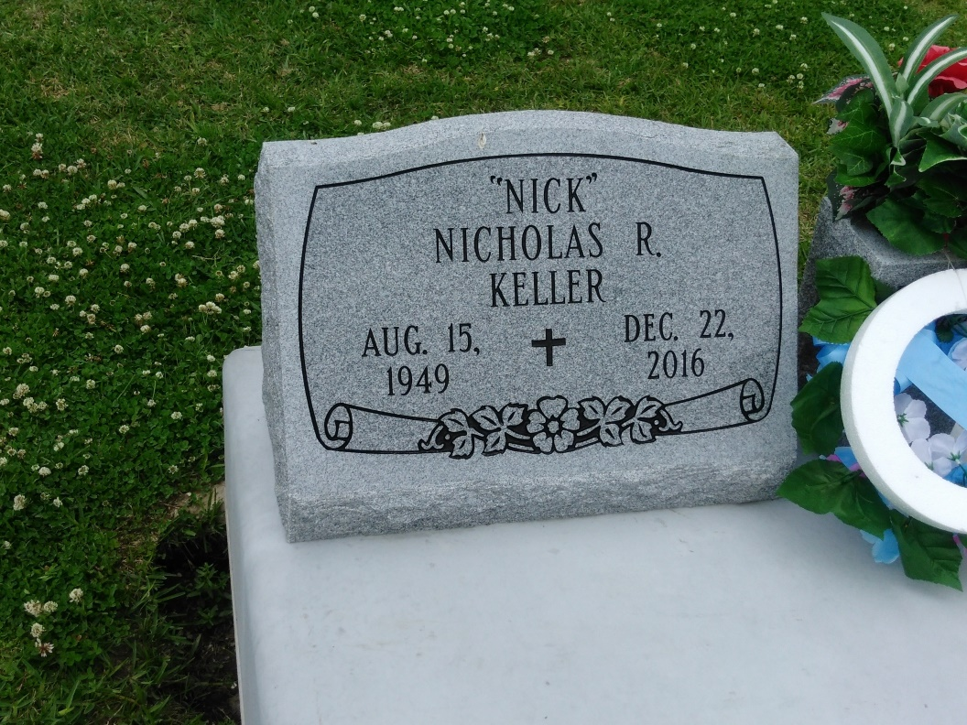

Photo by TMB

Nicholas "Nick" Keller, 67, a native and resident of Vacherie, LA departed this life on Thursday, December 22, 2016 at Thibodaux Regional Medical Center.   
 Visitation from 9:00 a.m. to Mass of Christian Burial at 11:00 a.m. on Wednesday, December 28, 2016 at Our Lady of Peace Catholic Church in Vacherie, LA. Burial will follow in the Church Cemetery.   
 Nicholas is survived by his wife, Patricia Keller; mother, Equilla Keller; son, Darren Keller; stepsons, Terrance Gray (Demictrick) and Dwayne Gray (Dedre); brothers, Lawrence and Edward (Odette) Keller; sisters, Rita and Lois Keller; five grandchildren; and a host of other relatives and friends.   
 He was preceded in death by his father, Armand Keller; nephew, Troy Keller; mother-in-law, Simon Gray; and step father-in law, Joshua Dumas.   
 Arrangements by Williams & Southall Funeral Home, 101 Loop 945, Donaldsonville, LA (225) 473-1900.

Published in Houma Today & The Daily Comet, Terrebonne Parish, LA from Dec. 27 to Dec. 28, 2016