Septemia (Gibson) Keller

November 29, 1962 – December 29, 2011

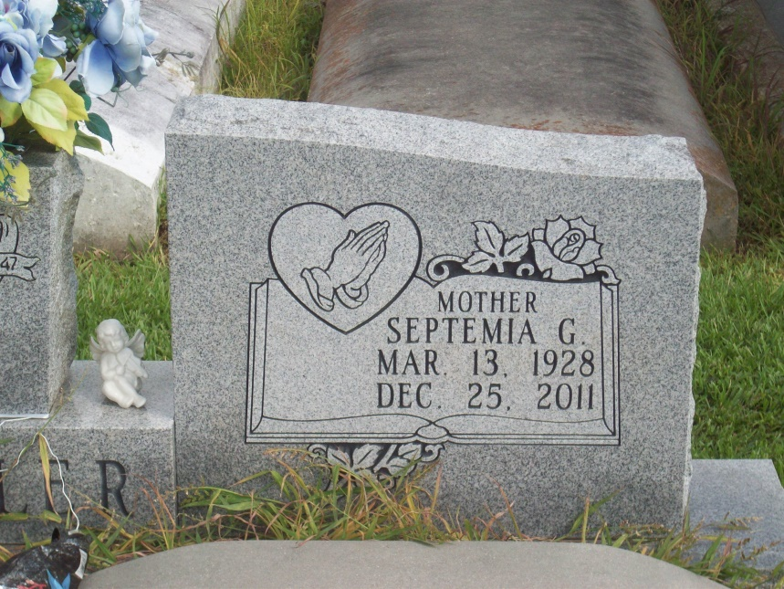

Photo by TMB

Ricky James Keller, of Vacherie, La. at Thibodaux Regional Medical Center on Tuesday, March 29, 2005. Son of Mr. & Mrs. Charles Keller. Father of Ricky Jr., Rakeem, Roje', Richel and R' Keyah. Brother of Theresa, Gayle and Lisa of Baton Rouge, Peggy (Malcolm) Kelly and Maxine (Alphonse) Spurlock of New Orleans, Troy Keller of Vacherie, La. and the late Charles, Kenneth and Linda Keller. Also survived by (1) godson Kenneth Keller, Jr., a host of aunts, uncles, nieces, nephews, cousins and friends. A native and resident of Vacherie, La. Age 42 years.  
  
Relatives and friends of the family, also priest and parishioners of Our Lady of Peace Catholic Church are invited to attend a Mass of Christian Burial on Thursday, March 31, 2005 at 11:00 AM from the Our Lady of Peace Catholic Church, Vacherie, LA. Father Michael A. Miceli, celebrant. Interment in church cemetery. Visitation at the church after 8:00 AM on Thursday.  
  
The Baloney Funeral Home, 399 Earl Baloney Dr., Garyville, LA 70051 (985) 535-2540, In Charge of Arrangements.

Times-Picayune, The (New Orleans, LA)

Wednesday, March 30, 2005