Vera Marie Keller
August 29, 1962 – September 23, 2025

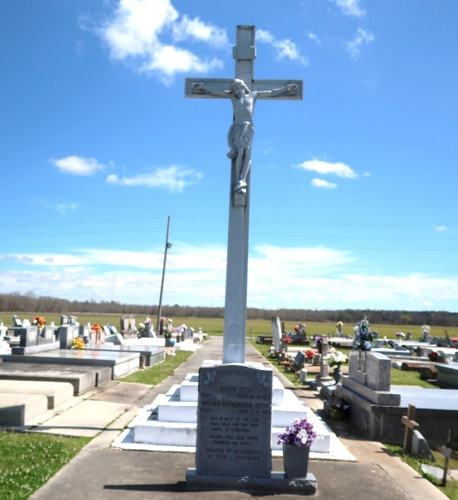

Born August 29, 1962, to the late Mr. and Mrs. Gufielle Keller, Vera was a proud citizen of Vacherie, La and a graduate of St. James High. She was known for her fun-loving spirit and a heart of pure gold. Vera dedicated over 30+ years of her life to working at McDonald's and 20+ years at La Fourche Arc, where she built lasting relationships and found joy in serving others.
Her greatest love, however, was her family. Vera was a devoted mother to her only son Bryan Patrick Keller; her greatest pride and joy in her life whom she cherished deeply, and a constant source of support and guidance to her nieces and nephews. She took immense pride in nurturing and instilling life lessons, wisdom, and love in each of them. Her legacy of kindness, hard work, and family devotion will forever be cherished.
Vera leaves to cherish her precious memories her son Bryan [Sany] Keller, her siblings: Calvin [Jeanette] Keller, Barbara Ann Keller, Mary Jane Keller, Gwendolyn Ann Keller, Patrick Mark Keller, Cornell [Abonda] Keller, and Grace [Brooks] Hamilton, her nieces and nephews: Kristen [Edward] Keller-Williams, Valerie [KG] Keller-Gates, Christopher [Pam] Keller, Kendra Keller, Regan [Nivia] Keller, Sr., Ashleigh Keller, Tre'an Nathan, Illyria Keller, Benjiman Burns, Nicholas Burns, Michael [Leslie] Keller, Patrick Steptore, Angie Steptore and a host of great nieces and nephews.
She was proceeded in death by her mother OraLee Laurent Keller, father Captain Gufielle Keller, brother Hardin James Keller, and life partner Roy “Shingy” Dumas.
A Mass of Christian Burial will be held on Saturday, September 27, 2025 at Our Lady of Peace Catholic Church, 13281 Hwy. 644, Vacherie, LA 70090. Visitation beginning for 10am followed by Mass for 1:00pm. Entombment Our Lady of Peace Catholic Church Cemetery.

Treasures of Life Funeral Services, Gramercy, Louisiana

