Gladys Stella (Webre) Kliebert

March 25, 1927 – December 14, 1995

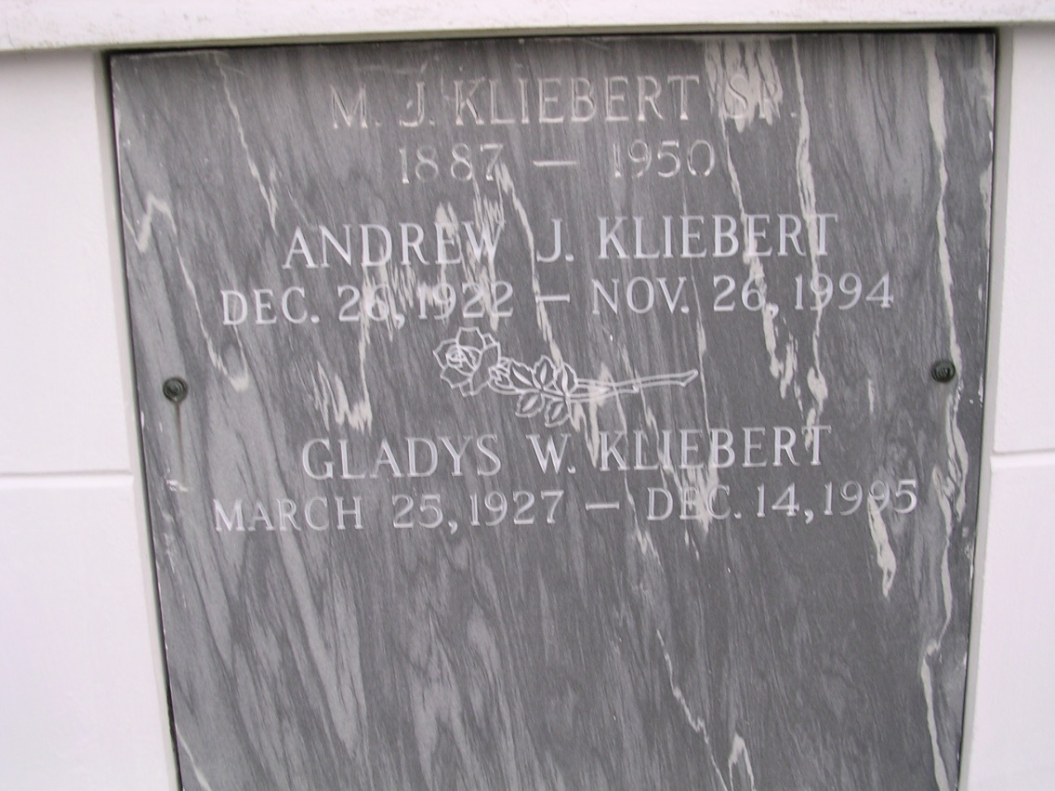

Photo by rrcar

A Mass of Christian burial will be celebrated at 10 a.m. Saturday at Our Lady of Peace Catholic Church in Vacherie for Gladys Webre Kliebert, a resident of Vacherie, who died Thursday, Dec. 14.

Visitation will be 6 to 10 p.m. today and 8 a.m. to Funeral time Saturday. Burial will be in the church cemetery.  
 She was the mother of Bradley, Eugene and Andrew Kliebert; sister of Demase Webre, Marguerite Stein, Mary Bare', Francis Williams, Agnes Wright and Bessie Rougee. She is also survived by four grandchildren.  
 She was preceded in death by her husband, Andrew J. Kliebert; parents, John and Uranie Webre; six brothers, Edward, Roy, Harris, Alvin, Norman and Guy Webre; and four sisters, Pamphile, Gertrude and Mae Webre and Mercedes Rodrigue.

Unknown source