Hubert James Kliebert

November 10, 1909 – December 11, 1989

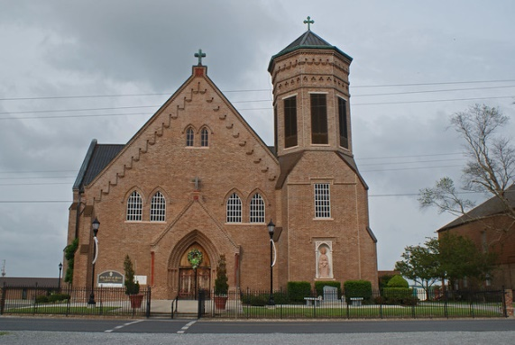

Died 12:30 a.m. Monday, Dec. 11, 1989, in Thibodaux. He was 80, a native and resident of Vacherie. He was a retired plantation overseer. Visiting at Our Lady of Peace Catholic Church, Vacherie, 8 a.m. until religious services at 11 a.m. Tuesday, conducted by Father Clarence Waguespack. Entombment in Our Lady of Peace Mausoleum. Survived by wife, Althea Webre Kliebert, Vacherie; three daughters, Mrs. Earl (Mary Anna) Laurent, Metairie, Mrs. Amelie K. Becnel and Mrs. Leroy (Therese) Folse, both of Vacherie; two sons, Remie Kliebert, Slidell, and Milton "Mitch" Kliebert, Vacherie; five sisters, Germaine Scioneaux, Vacherie, Eve Robinson and Marie Roussel, both of New Orleans, Sophie Claudy, Natchitoches, and Rita Donaldson, St. Gabriel; 13 grandchildren; and six great-grandchildren. Preceded in death by parents, Lezin and Amelie Oubre Kliebert; four brothers, Eno, Lionel, Henry and Lezin Kliebert Jr. He was a member of Woodmen of the World. Ourso Funeral Home, Donaldsonville, in charge of arrangements.

The Advocate, Baton Rouge, LA; December 12, 1989.

Contributed by Ron Manley