Cecile “Nan” (Ockmond) Labat

November 22, 1916 – April 27, 2007

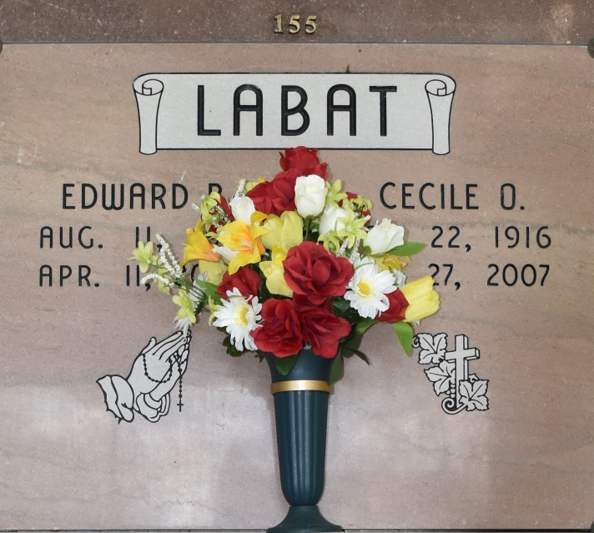

A loving wife, mother, grandmother and great-grandmother, she died Friday, April 27, 2007, at Ollie Steele Burden Manor at the age of 90. She was a resident of Baton Rouge and a native of Vacherie.

Visiting at Our Lady of Peace Catholic Church, Vacherie, on Tuesday, May 1, from 8:30 a.m. until religious service at 11 a.m., conducted by the Rev. Michael Miceli. Recitation of the rosary on Tuesday at 9:30 a.m. Entombment in the church mausoleum.

Survived by three great-grandchildren, Courtney, Heather and Gabrielle Labat, all of Gonzales; two grandchildren, Thomas Jr. and wife Melanie Labat of Gonzales and Ann Marie Labat and friend Lois Samer of Fort Collins, Colo.; son and daughter-in-law, Thomas Sr. and Mary Ann Schexnayder Labat of Gonzales; sister, Clementine Ockmond Rodrigue of Chackbay; and brother and sister-in-law, George Jean and Inez Ockmond of Brusly. Preceded in death by husband, Edward B. Labat; granddaughter, Jacinta Cecile Labat; father, Bienvenue Ockmond; mother, Faustina Torres Ockmond; and brothers, Andrew, Roger and Louis Ockmond. She was a lifetime member of Our Lady of Peace Catholic Church. Special thanks to Hospice of Baton Rouge and St. Clare Manor. Alexander Funeral Home of Lutcher is in charge of arrangements.

The Advocate, Baton Rouge, LA

April 29 - 30, 2007