Edward B. Labat

August 11, 1917 – April 11, 2000

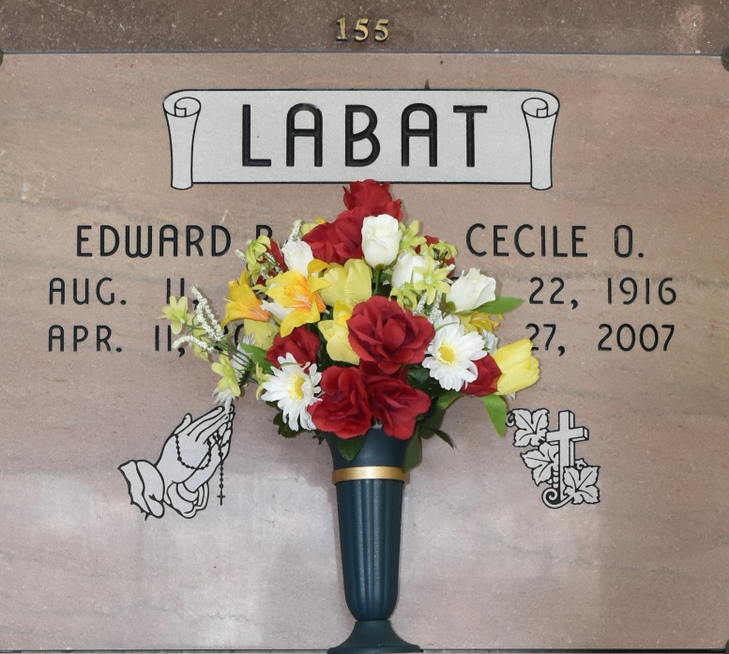

A retired employee of Southdown Sugars in Vacherie and a native and resident of Vacherie, he died Tuesday, April 11, 2000, at his home. He was 82. He was the beloved husband of Cecile Ocmand Labat; father and father-in-law of the Rev. Mr. Thomas E. Labat Sr. and Mary Ann S. Labat of Gonzales; grandfather of Ann Marie Labat of Fort Collins, Colo., and Thomas E. Labat Jr. of Gonzales, and the late Jacinta C. Labat; great-grandfather of Courtney, Heather and Gabriell Labat; son of the late Louis E. and Anita Oubre Labat; brother of Daisy L. Falgoust, Aline L. Folse and Nelson Labat, all of Vacherie, Edmond "Tim" Labat and Ella L. Buquoi, both of Baton Rouge, and the late Willie Labat and Marie L. "Nin" Schexnayder. Visiting at Our Lady of Perpetual Help Catholic Church, Vacherie, from 6 p.m. to 9 p.m. Thursday and after 8 a.m. Friday. Relatives and friends of the family are invited to attend Mass of Christian Burial at the church at 10 a.m. Friday. Entombment in church mausoleum. He was a parishioner of Our Lady of Perpetual Help Catholic Church, Vacherie, and a member of Woodmen of the World. In lieu of flowers, enrollment of masses or memorial donations to a favorite charity preferred. Arrangements entrusted to H.C. Alexander Funeral Home of Lutcher.

Advocate, The (Baton Rouge, LA) - Thursday, April 13, 2000  
Contributed by Jane Edson