Lester Leonard Labat

August 29, 1931 – May 7, 2019

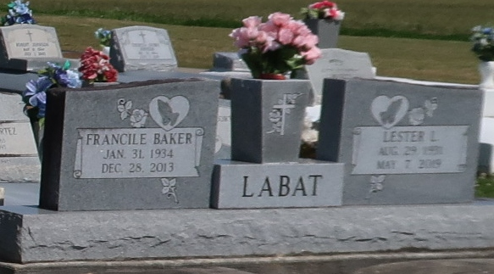

Lester Leonard Labat passed away at his home on Tuesday, May 7, 2019 at the age of 87.   
 Beloved husband of the late Francile Baker Labat for 59 years. Loving father of Jenny Labat Clement (Curry), Kathyrn Labat Bourgeois (Allen), Linda Labat Taylor, Larry L. Labat (Lisa), Denis J. Labat, Russell P. Labat and Joseph D. Labat (Wendy). Proud grandfather of Albert (Stephanie), Bradley (Erika), Byron (Brandy), Melissa (Steven), Heidi (Christopher), Dustin (Adrienne), Jana, Evan, Trevor, Madison and Gavin. Great grandfather of Anthony, Zachary, Brody, Elyse, Jase, Gabrielle, Hunter, Shelby and Sophia. Also survived and fondly remembered by many nieces, nephews, cousins and friends.  
 Preceded in death by his parents Richard Labat and Selma Falgoust Labat, his brothers and sisters and two dear great grandchildren James Bourgeois and Scarlett Bardy. Lester was born on August 29, 1931 in Vacherie, LA. He was a longtime resident of Chalmette, LA before settling back in Vacherie, LA. He was a United States Air Force Veteran and proudly served in the Korean War. Lester retired from Kaiser Aluminum after many years of dedicated service. He was strong in his faith and was a parishioner of Our Lady of Peace Catholic Church. He will be forever remembered and deeply missed by his family, friends and all of those whose lives he touched.   
 Relatives and friends are invited to attend a visitation to be held at OUR LADY OF PEACE CATHOLIC CHURCH, 13281 LA 644, Vacherie, LA on Tuesday, May 14, 2019 from 9:00 AM – 11:00 AM. A Funeral Mass will begin at 11:00 AM. He will be laid to rest with military honors in Our Lady of Peace Cemetery, Vacherie, LA.  
  
St Bernard Memorial Funeral Home, Chalmette, LA