Rumsey Louis Labat

August 29, 1913 – February 1, 1979

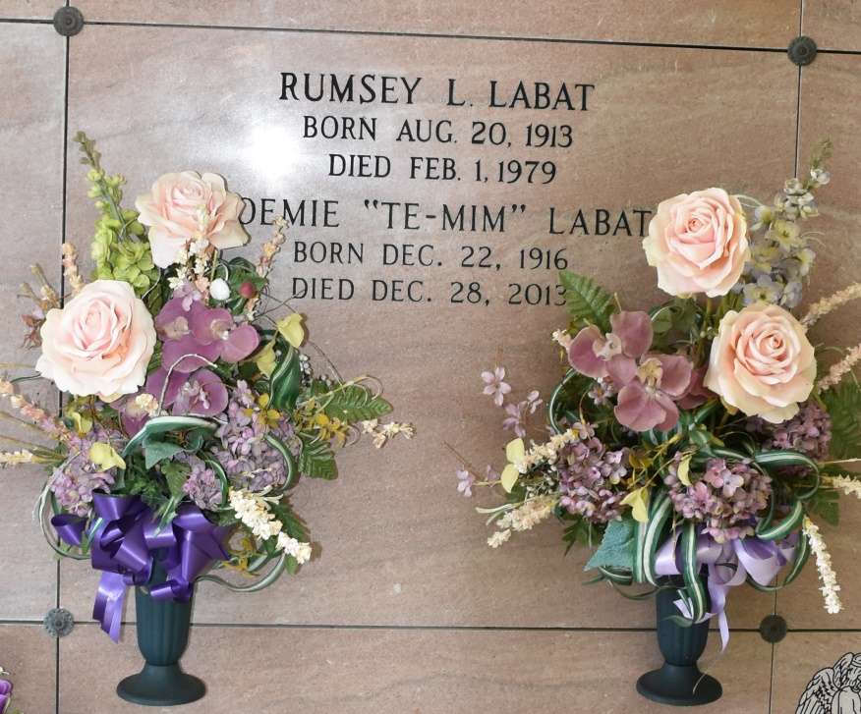

Rumsey Louis Labit, native and resident of Vacherie, died Feb. 1, [1979] at 6:30 p.m. in New Orleans at the age of 65.

Visitation at the K. C. Home in Vacherie will begin today at 5 p.m. and will continue until funeral time. Funeral services are scheduled for 10:30 a.m. at the funeral home, followed by religious services at St. Phillip Catholic Church. Interment will take place in Our Lady of Peace Cemetery.

He is survived by his wife, Noemie Falgoust Labit, one son, Richard Labit of Thibodaux; two daughters, Mrs. Earl (Peggy) Roussel of Luling, and Mrs. Simon (smudged) of Vacherie; four brothers, Lester of Chalmette, Roy of Westwego, Dudley of St. James and Claude of Vacherie; two sisters, Mrs. Albert (Mae) Simon and Mrs. Elmo (Alice) Becnel of Vacherie and 10 grandchildren.

He was preceded in death by his parents, Richard and Selma Falgoust Labit and two brothers, Ikey and Sidney Labit.

Arrangements are being handled by Thibodaux Funeral Home.

Unknown newspaper clipping