Thom John Landry

September 23, 1938 – October 26, 2018

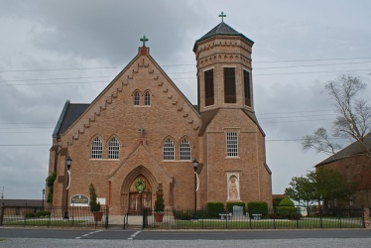

Thom John Landry, 80, a native of Choupic and resident of Vacherie, passed away on Friday, Oct. 26, 2018, while surrounded by family and friends.  
 A visitation will be held at Our Lady of Peace Catholic Church on Wednesday, Oct. 31, 2018 from 8 a.m. until funeral time. A Mass of Christian Burial will take place at 11 a.m. Interment will follow in the church cemetery.  
 He is survived by his loving wife of 59 years, Alida Simon Landry; children, Scott Landry (Elizabeth), Shane "Pogo" Landry (Margaret) and Lorna Larousse (Danny), all of Vacherie; grandchildren, Lance Landry (Kayla), Ryan Larousse (Paula), Rusty Larousse (Ashley), Bryce Larousse, Remi Landry and Hannah Landry, all of Vacherie, and Ross Landry (Brenna) of Georgia; great-grandchildren, Lillian and Layton Landry, Isabella Larousse, and Madison and Hayden Schexnayder; and sisters, Betty Boudreaux (Albert), Dorina Landry, Ruth Tabor (Kenneth) and Ruby Adams (John).  
 He was preceded in death by his parents, Wilmer and Marie Landry; twin brother, Jerry "Rock" Landry; sister, Dianna Jouclas; and uncle, Whitney "Nick" Landry.  
 Thom was a retired member of Local 60 Plumbers and Steamfitters.  
 The family would like to thank Dr. Roland Waguespack, Mary Morvant, St. Joseph Hospice and all family, neighbors and friends for their loving care.  
 Thibodaux Funeral Home Inc. is in charge of arrangements.

Published in Houma Today & The Daily Comet, Terrebonne Parish, LA from Oct. 27 to Oct. 29, 2018