Ulger F. Landry

March 9, 1910 – January 15, 2000

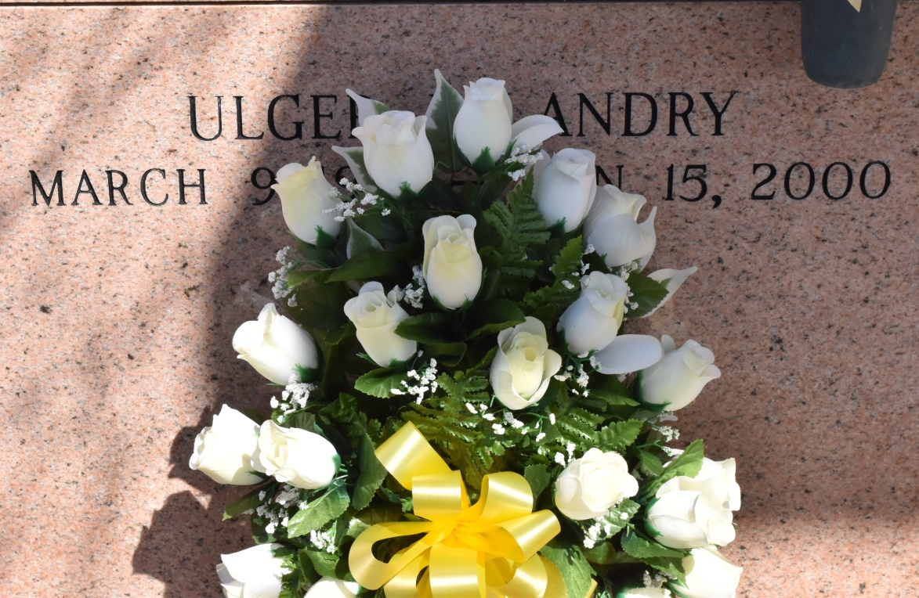

A resident of Vacherie, he died at 9:55 a.m. Saturday, Jan. 15, 2000. He was 89, born March 9, 1910, in Chackbay. Visiting at Our Lady of Peace Catholic Church, Vacherie, from 8 a.m. until Mass of Christian Burial at 10 a.m. Monday. Interment in Our Lady of Peace Cemetery. Survived by his wife, Edianne Brock Landry; three daughters, Rose L. Falgoust, Gloria L. Boe and Dorothy L. Guillot; a brother, Foster Landry; a sister, Lillian Caillouet; 14 grandchildren, 28 great-grandchildren and seven great-great-grandchildren. Preceded in death by parents, Froizin Landry and Laiza Trosclair Landry; five brothers, Louis, Valmont, Luke, Amelius and Wilson; and a sister, Frazine L. Rodrigue. Landry's Funeral Home in charge of arrangements.

Advocate, The (Baton Rouge, LA)

Monday, January 17, 2000  
Contributed by Jane Edson