Elizabeth Laurent

1939 – January 15, 2010

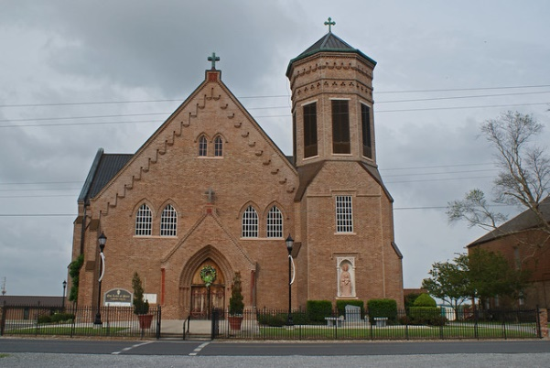

Elizabeth Laurent, 71, a native and resident of Vacherie, died Friday, Jan. 15, 2010.  
 Visitation will be from 8 a.m. to funeral time Saturday at Our Lady of Peace Catholic Church in Vacherie. Service will be 10 a.m. Saturday at the church conducted by the Rev. Michael Mecili, with burial in the church cemetery.  
 She is survived by one son, John K. Sr. and wife, Trudy Laurent of Vacherie; two daughters, Lena L. and husband, Clifford Keller of Vacherie, and Yolanda and husband, Derrick B. Collins of Gray; two sisters, Shirley and husband Joseph Steib of Marrero, and Geraldine Smith of Vacherie; one brother, Joseph N. and wife, Delores Laurent of Vacherie; her brother-in-law, Captain Gufielle Keller of Vacherie; five grandchildren; and a host of nieces, nephews, relatives and friends.  
 She was preceded in death by her parents, Maurice and Amelia Lemieux Laurent; one sister, Ora Lee Keller; and her brother-in-law, Lionel Smith Jr.  
 She was a homemaker, a parishioner of Our Lady of Peace Catholic Church, a member of Good Children Benevolent Society and the Perpetual Adoration Group.  
 Williams and Southall Funeral Home of Napoleonville is in charge of arrangements.

Unknown source