Veronica (Steib) Lemieux

October 17, 1918 – September 10, 2014

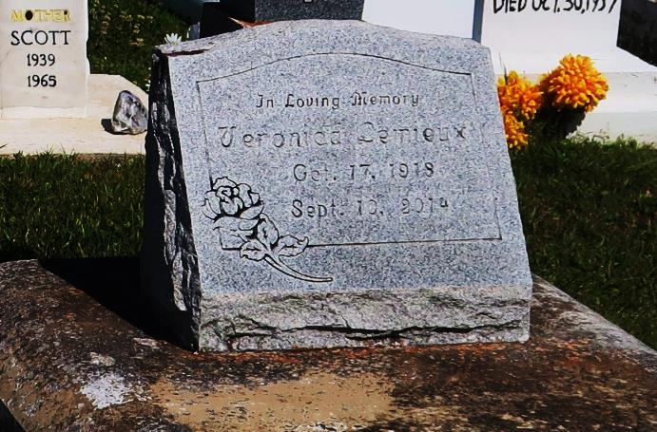

Veronica Lemieux passed away on Wednesday, September 10, 2014, at the age of 95 years old. Daughter of the late Rosemond and Virginia Phillips Steib. Wife of the late Adam Kermit Lemieux, Sr. Mother of Frances Jackson, Alriner (Morris) Cooper, Joseph (Dorean) Lemieux, Marvin (Karen) Lemieux, Adam K. Lemieux, Jr., David (Leilani) Lemieux, and Natalie (Gerald) Joshua. Sister of Viola Narcisse, the late Auriean, Sylvester, Clerville, Landry, Rosemond, Jr., Valerie, Elodee, and Francine Steib. Also survived by a host of grandchildren, nieces, nephews, cousins, other relatives and friends.

Funeral services will be held at Our Lady of Peace Catholic Church, 13281 La. Highway 644, Vacherie, La., on Wednesday, September 17, 2014, for 11:00 a.m. Visitation will be from 9:00 a.m. until time of service. Father Michael Miceli will be officiating. Interment will be at Our Lady of Peace Catholic Church Cemetery, Vacherie, La. Funeral entrusted to The Baloney Funeral Home, LLC, 1905 W. Airline Highway, LaPlace, LA, (985) 224-8460. Condolences can be expressed at [www.baloneyfuneralhome.com.](http://www.baloneyfuneralhome.com/)

The Advocate, Baton Rouge, LA

September 13-17, 2014