Cornelius Lewis, Sr.

January 31, 1939 – January 22, 2010

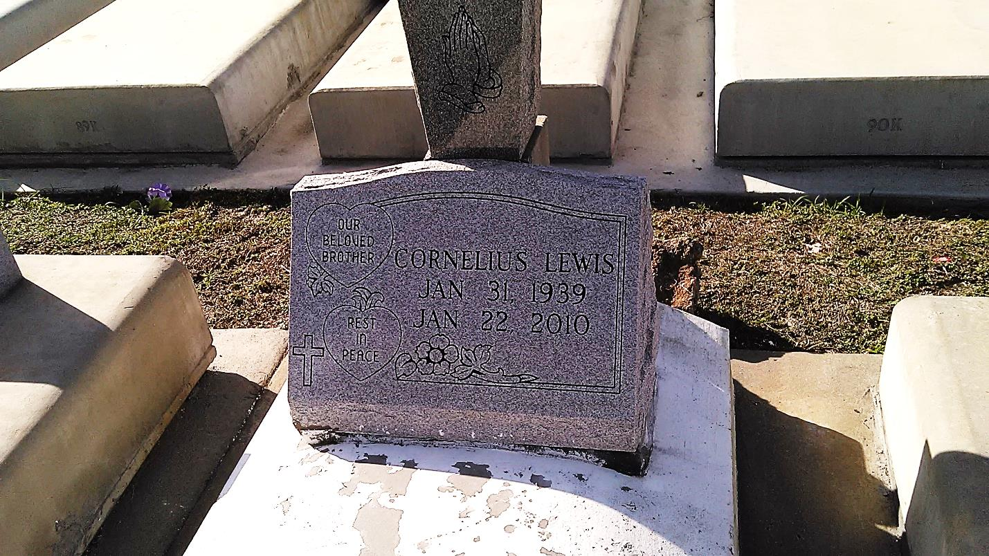

Photo by TMB

Cornelius (Jack Moe) Lewis departed this life at his residence in Bridge City, La. on Friday, January 22, 2010. Husband of the late Anna Lee Weber Lewis. Father of Cornelius Lewis, Jr. and Linda Lewis. Stepfather of Anthony Weber. Son of the late Amy Bartholomew and Reney Lewis. Brother of Dorothy (Elton) Wilson, Warren (Dale) Matthews of Hahnville, La. and Nelson (Lillie) Matthews of New Orleans, La. and the late Eula Mae Lewis. Devoted nephew of Alexander (Priscilla) Lewis and Steve (Laura) Lewis. Devoted uncle of Thaddeus Bazile. Beloved friend of Selena Pugh. Also survived by sisters-in-law, brothers-in-law, aunts, uncles, nieces, nephews, other relatives and friends. Age 70 years. A native of St. John Parish, La. and a resident of Bridge City, La.  
 Relatives and friends of the family are invited to attend the Funeral Service at Holy Garden of Angel Catholic Church, 1701 Bridge City Ave., Bridge City, La. on Friday January 29, 2010 at 10:00a.m. Visitation will begin at 8:30a.m. until service time at the above named church. Interment: Our Lady of Peace Cemetery - Vacherie, La.

Unknown source