Claude Louis Sr.
June 5, 1938 - December 30, 2025

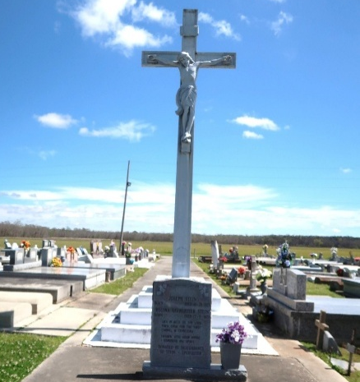

Rev. Claude Louis Sr. was born June 5, 1938 (87 years old) in Vacherie LA to Edward Lewis and Cecile Alexis Lewis. He departed this earthly life on Tuesday December 30, 2025 while residing at the Southeast Louisiana Veterans Home in Reserve LA. Rev. Claude Louis Sr. served in the United States Army and was honorably discharged with the rank as an E-5 sergeant. His last duty assignment was at LaPaz, Bolivia. He received the National Defense Service Medal and the Good Conduct Medal (Twice).
Rev. Claude Lous Sr. was ordained a minister under the late Rev. Alexander & Rev. Joseph at the Second Baptist Church (now known as Greater Deliverance Full Gospel Ministry) in South Vacherie LA and in 1978 was elected/installed as the Pastor. He served faithfully as the Pastor for two years and the late Elder Eddie Narcisse Sr. was later installed as Pastor in 1980.
On June 29, 1963 Rev. Claude Louis Sr. married his devoted wife Phillidee Scioneaux and they were married for 63 years. Together they produced four children: Claude J. Louis Jr. (Debbie), Phyllis M. George (Eric), Laura M. Watts and Avery Louis Sr.
He was preceded in death by his parents Edward and Cecile Lewis, his brothers Maurice Lewis, Albert Lewis, and Edward Lewis Jr.; his sisters Doretha Black, Dorothy McGraw, Claudia Lewis, Gloria Mae Meadius, Viola Barthelomew, and Rosalie Narcisse.
He leaves to cherish his memories a loving and devoted wife, Phillidee Louis, his children, grandchildren, great grandchildren and a host of other nieces and nephews, relatives, friends, and church family to rejoice in his memory.
A Celebration of Life will be held on Friday, January 9, 2026 at New Hope International Worship Center, 21490 LA-20, Vacherie, LA 70090; visitation from 9:00am to 11:00am followed by the service for 11:00am. Entombment Our Lady of Peace Catholic Church Cemetery.

Treasures of Life Funeral Services, Gramercy, Louisiana
January 20, 2026

