Inez Marie (Ockman) Marse

June 20, 1920 – October 18, 2016

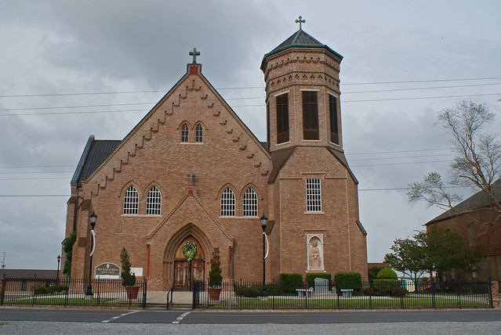

Inez Marie Ockman Marse, age 96, was born on June 20, 1920 and passed away on October 18, 2016 at Thibodaux Health Care Center with her loving family at her side. She was a native of Vacherie, LA.  
 Service on Saturday, October 22, 2016 at Our Lady of Peace in Vacherie, funeral time at 11 a.m. The celebrant will be Fr. Reuben Dykes. Burial in the church cemetery.  
 She is survived by her four children, Ronald (Emily) Marse of Thibodaux, Brenda (Elton) Chenier, Carroll (Linda) Marse, and Wayne (Belinda) Marse all of Vacherie. Her seven grandchildren: Julie (Glenn) Chiasson, Troy (Jaime) Chenier, Heath Marse, Benjy (Helen) Marse, Kenny (Heidi) Marse, Lacy (Richard) Sosa, and Emmy (Clint) Becnel. Eleven great-grandchildren: Katie (Devin) Hymel, Haley Chiasson, Josie Chenier, Mallory Marse, Lexi Marse, Lindsay Chenier, Cody Chiasson, Karli Marse, Ty Marse, Sydnie & Tycen Becnel, and two step great-grandchildren Trace Juneau and Carter Thibodaux; her two brothers, Joseph “Joe” and William (Hazel) Ockman.  
 She was preceded in death by her husband, Philip Joseph Marse; her parents, Wilhem Coleman and Josephine Brock Ockman; her brother Edwin “Edvone” Ockman and granddaughter-in-law Kristi Falgoust Marse.  
 ”Memere” as she was known was a very loving, kind and generous mother, grandmother and great-grandmother who was always concerned for her family even to the end. We were all so blessed to have her in our lives and she will be greatly missed by all.   
 A special thank you to all the family and friends who loved and cared for her over the last few weeks.  
 Thibodaux Funeral Home, Inc. is entrusted with handling of funeral arrangements.

Unknown source