Henry Melancon

June 20, 1932 – February 14, 2011

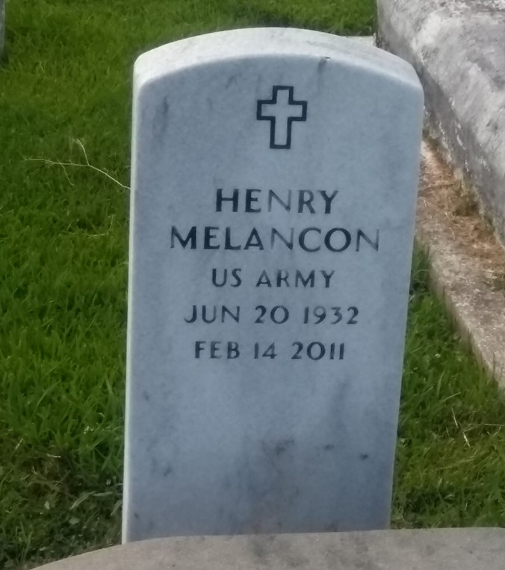

Photo by TMB

Henry (Dee Dee) Melancon departed this life on Monday, February 14, 2011 at Thibodaux Regional Hospital. Husband of the late Pat Melancon. Father of Tess Verrett and Ashely Melancon, and the late Wardell Melancon. Son of the late Alexander and Lorenza Melancon. Brother of Eve Mae Hall, and the late Alexander, Joseph, and Ferdinand Melancon, Lorenza Favorite, Rita Carter, Virginia Williams, and Emily Weatherspoon. Brother in law of Lawrence Hall and Fletcher Weatherspoon, also survived by a host of other relatives and friends. Age: 78 years a native and resident of Vacherie, La.

Unknown source