Leroy P. Morvant Jr.

1951 – December 11, 2009

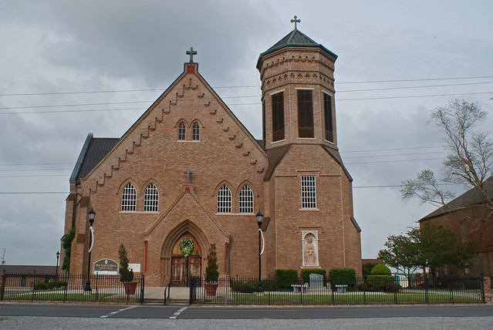

Leroy P. Morvant Jr., 58, a native of Thibodaux and resident of Vacherie, died at 4:30 p.m. Friday, Dec. 11, 2009.  
 Visitation will be from 8 a.m. to funeral time Tuesday at Our Lady of Peace Catholic Church in Vacherie. Mass will be 11 a.m. Tuesday at the church, with burial in the church cemetery.  
 He is survived by his wife of 38 years, Marilyn Clement Morvant; three sons, Max Morvant and wife, Michelle; Kenny Morvant and wife, Kerri, and Doug Morvant; one brother, Jason Morvant and wife, Vicky; two sisters, Judy M. Useau and husband, Rusty, and Lisa M. Thibodeaux and husband, Norman; and eight grandchildren, Gavin, Tate, Emma, Keni, Michael, Cloe, Ethan and Luke.  
 He was preceded in death by his parents, Leroy and Evelyn Duroche Morvant; and one brother, Randy J. Morvant.   
 He was a retired operation specialist for Union Carbide.  
 Thibodaux Funeral Home is in charge of arrangements.

Unknown source