Aimee (Oubre) Narcisse

June 9, 1910 – July 2, 2005

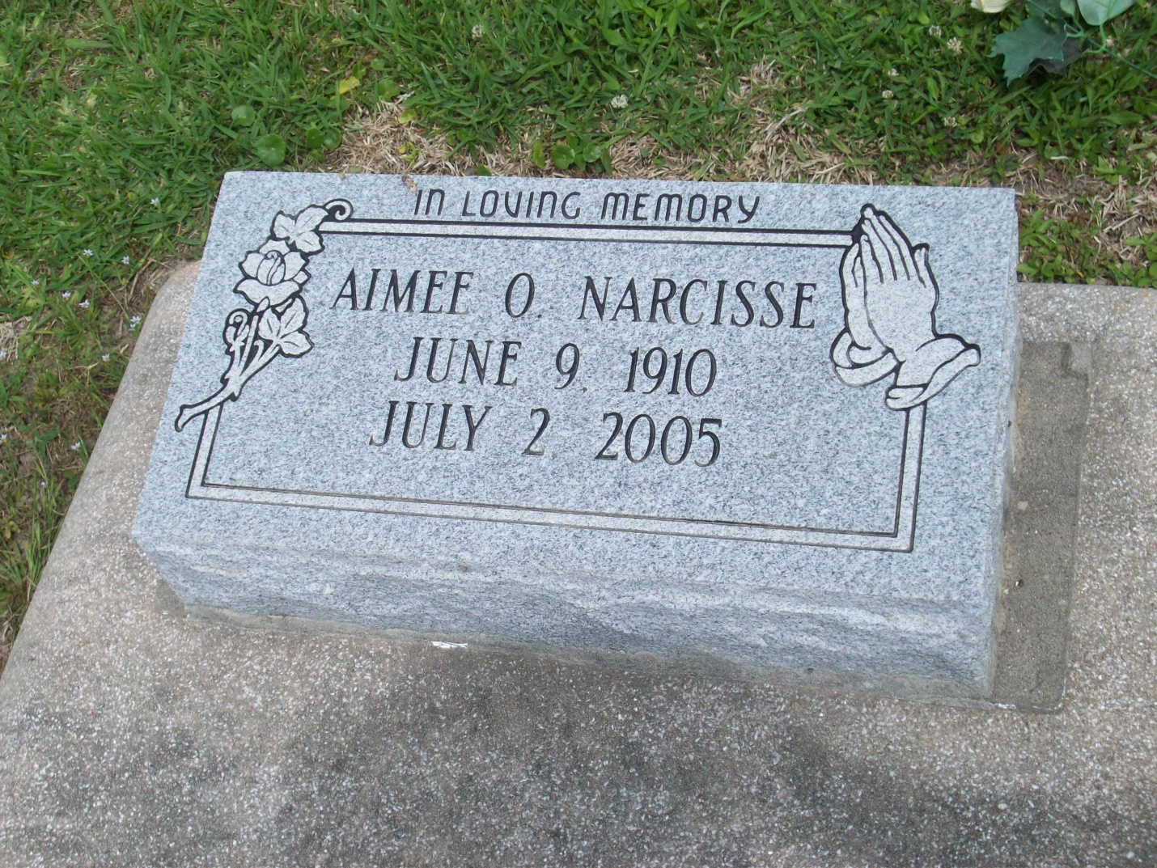

Photo by TMB

Aimee Oubre Narcisse, 95, a native and resident of Vacherie, died July 2. She was the wife of the late Swifton Narcisse. She is survived by her siblings Ursin and Armalise Oubre.

She was preceded in death by her parents Armalise and Catherine Oubre.

Services will be held today at Our Lady of Peace Catholic Church, Vacherie, with interment in the church cemetery.

Unknown source