Joseph Clifton Narcisse, Jr.

November 20, 1934 – January 10, 2014

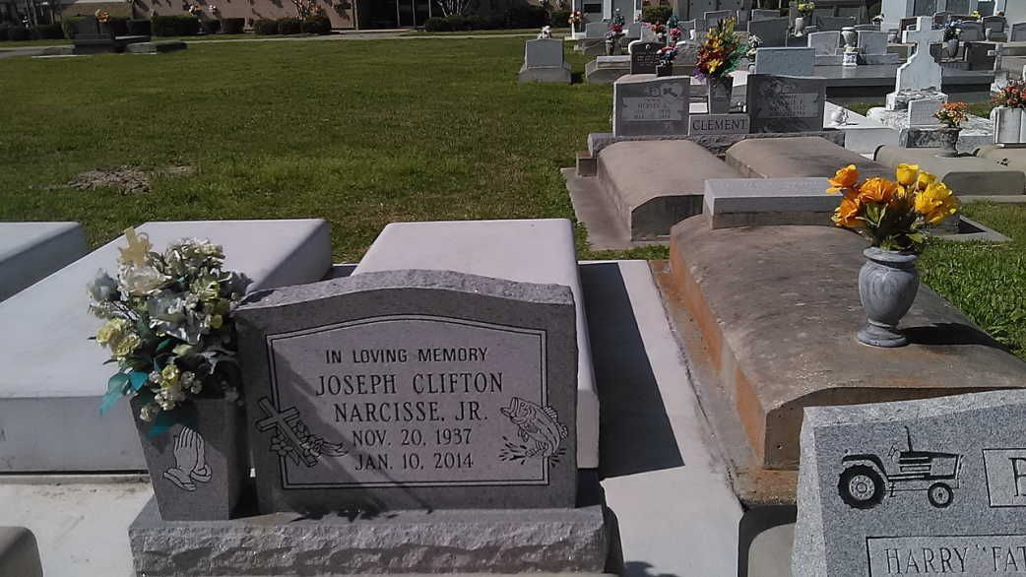

Photo by TMB

JOSEPH CLIFF NARCISSE on Friday, January 10, 2014 at Canon Hospice, Jefferson, Louisiana. Husband of Bernadette A. Narcisse. Father of Gregg Anthony (Felicia) Narcisse of Crete, Ill, Ron Anthony (Sherrie) Narcisse of Ama, LA, Marella Narcisse of St. Antonia, TX, Robert Narcisse, Damien Schexnayder, Barbara Davis and Janette Jefferson. Brother of Ronald Narcisse (Mable), Ramona King, Jacquelyn Skinner (Douglas), Diane Adams (Milton), Jackie, Larry (Peggy), Darryl, and Teddy (Elizabeth) Narcisse, the late Marjorie N. Phillip and Odessa Narcisse. Also survived by 13 grandchildren, 1 great grandchild and a host of nieces, nephews, cousins, other relatives and friends. Age 76 years. A native of Vacherie, LA and a resident of Ama, LA Relatives and friends of t he family, also priest and parishioners of St. Mark and St. Anthony Catholic Churches and all neighboring churches are invited to attend the Funeral Mass at St. Anthony of Padua Catholic Church, 234 Angus Drive, Luling, LA on Saturday, January 18, 2014 at 11:00 AM. Father Ed Lauden, Celebrant. Interment Our Lady of Peace Catholic Church Cemetery, Vacherie, LA. Visitation at the above named church from 9:00 AM until Mass time. SERVICED BY ROBOTTOM

The Times-Picayune, New Orleans, Louisiana

Jan. 16 to Jan. 17, 2014