Marie Inez (Philip) Narcisse

February 2, 1923 – August 5, 2016

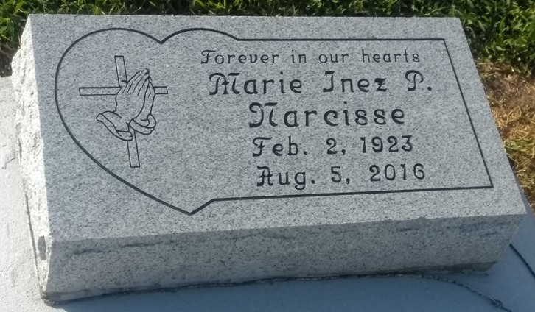

Photo by TMB

Marie Inez Philip-Narcisse died Friday, August 5, 2016 at her daughter's residence in Baton Rouge, LA. She was 93 a native and life-long resident of Vacherie, LA.

Visiting at Our Lady of Peace Catholic Church in Vacherie, LA on Saturday, August 13, 2016 from 9:00am to the Mass of Christian Burial at 11:00am. Burial in the church cemetery. Arrangements by Williams & Southall Funeral Home, 5414 Hwy. 1, Napoleonville, LA 985 369-7231. To sign guest book or offer condolences, visit our website at [www.williamsandsouthallfuneralhome.com](http://www.williamsandsouthallfuneralhome.com).

Advocate, The (Baton Rouge, LA)

Thursday, August 11, 2016

Contributed by Jane Edson

*****

NARCISSE: MARIE INEZ PHILIP-NARCISSE: Died Friday, August 5, 2016 at her daughter's residence in Baton Rouge, LA. She was 93 a native and life-long resident of Vacherie, LA. Visiting at Our Lady of Peace Catholic Church in Vacherie, LA on Saturday, August 13, 2016 from 9:00am to the Mass of Christian Burial at 11:00am. Burial in the church cemetery. Survived by 1 daughter, Sandra Wicker of Baton Rouge, LA; 2 grandsons, James C. Wicker III, and Nicholas Washington; 2 great granddaughters, Jacie and Carlie Wicker; Also a host of nieces, nephews, godchildren, other relatives and friends. Preceded in death by her husband, Lender Narcisse; 2 sisters, Marguerite P. Mitchell, and Maggie P. Dumas. Arrangements by Williams & Southall Funeral Home, 5414 Hwy. 1 Napoleonville, LA 985-369-7231.

Williams & Southall Funeral Home, Inc., Napoleonville, LA