Carl Osborne

February 22, 1902 – January 10, 1961

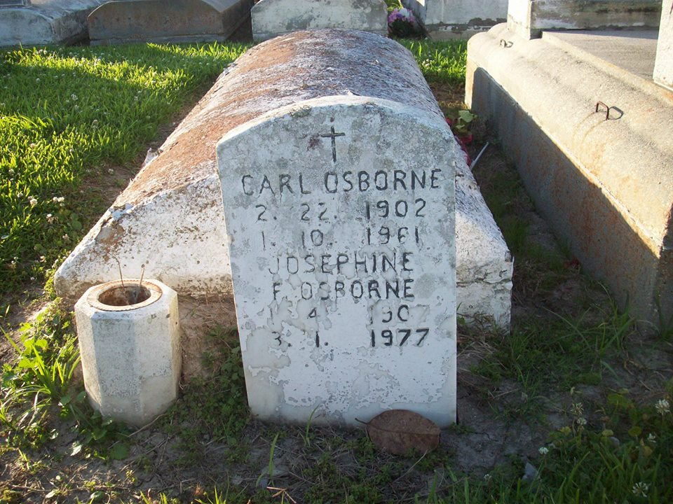

Photo by TMB

OSBORNE – of 3647 Tchoupitoulas Street, on Tuesday, January 10, 1961 at 4:35 o’clock a.m. Carl Osborne, beloved husband of Mrs. Josephine Favorite Osborn; father of Jerold, Morris and Ulysses Osborne, Mrs. Josephine Leonard, Mrs. Mayola Yung, Mrs. Augustine Jones, Mrs. Joyce Marie Ackline and Miss Rose Marie Osborne; brother of Brazile Osborne, Mrs. Rose Dumas and Mrs. Althea Keller. Also survived by 12 grandchildren, nieces, nephews and other relatives.

Relatives and friends of the family, also parishioners Blessed Sacrament Catholic church, emplyes of T. Smith and Sons, and Sara Mayo hospital, are respectfully invited to attend the wake and recital of the Rosary on Friday, January 13, 1961, at 6:30 o’clock p.m. at the late residence and funeral Saturday, January 14, 1961, at 9:00 o’clock a.m. Religious services at the residence. Father Grant Higgins, S.S.J. officiating.

Interment Vacherie cemetery (Vacherie, La.) Federal Funeral Home, Inc., in charge.

Unknown newspaper clipping

Contributed by TMB