Eva Mae (Weber) Oubre

April 13, 1932 – June 14, 1995

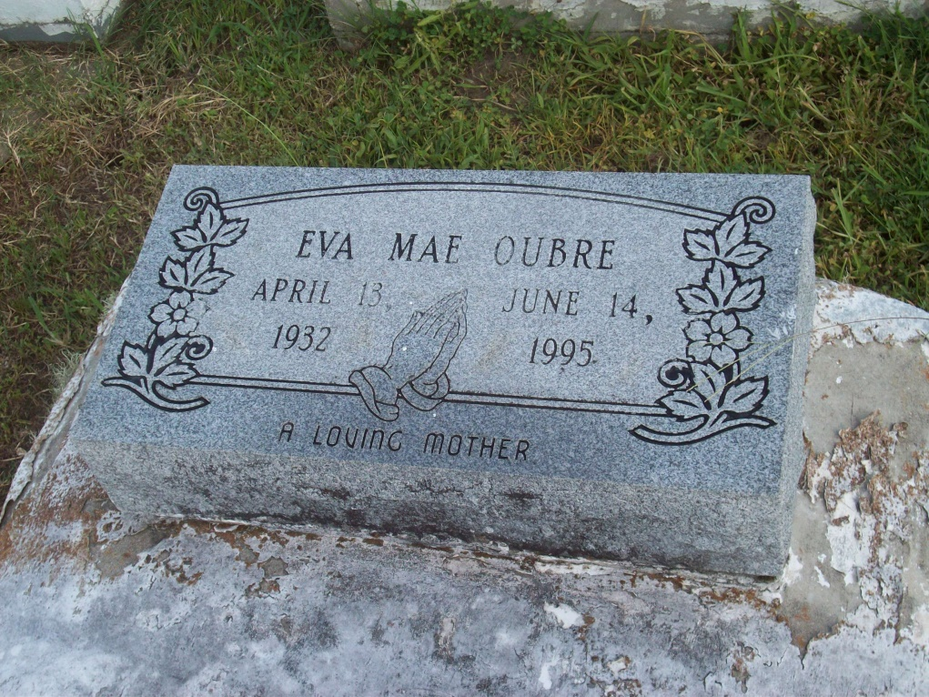

Photo by TMB

Eva Mae Oubre died Wednesday, June 14, 1995, in Humble, Texas. She was 63, a native and resident of Vacherie. She was a retired St. James Parish schools cafeteria worker.

Visiting at St. James Catholic Church, St. James, 8 a.m. until religious services at 10 a.m. Monday, conducted by the Rev. Louis T. Oubre, assisted by the Rev. Howard Hall. Burial in Our Lady of Peace Catholic Cemetery, Vacherie.

Survived by two daughters, Marie L. Oubre, Humble, and Janessa P. Oubre, Vacherie; two sons, the Rev Louis T. Oubre, Morganza, and Bruce T. Oubre, Gretna; a sister, Hazel W. Brown, Vacherie; two brothers, Peter C. Weber, Sacramento, Calif.; and Robert Weber, New Orleans; four grandchildren; and a host of nieces, nephews, other relatives and friends. Preceded indeath by husband, Paul Ergan "Shawee" Oubre; and parents, John M. Weber and Blanche A. Weber.

Unknown source