Freddie P. Oubre, Sr.

August 1, 1922 – January 25, 2001

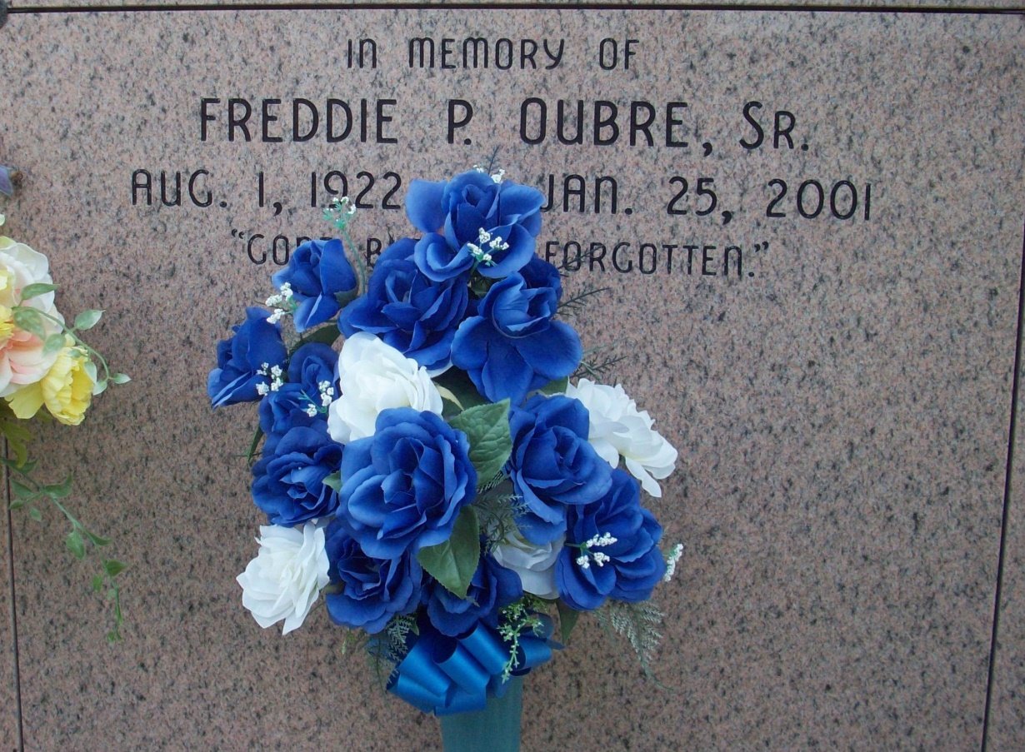

Photo by TMB

Vacherie - Freddie Pierre Oubre Sr., 78, a native and resident of Vacherie, died Jan. 25. He was the husband of Pauline Philip Oubre and father of Catherine Pedescleaux and Freddie Jr., Raymond and Michael Oubre. He was also the son of Amelise Sr. and Catherine Dumas Oubre, and brother of Aimee Narcisse, Amelise Jr., and Ursin Oubre Sr., and the late Norine Domino, Josephine Scott, and Catherine, Eddie, Joseph, and Oscar Oubre. He is also survived by seven grandchildren and three great-grandchildren. He was a retired school bus driver. Services were Jan. 30 at Our Lady of Peace Catholic Church, South Vacherie, with interment in the church mausoleum.

Unknown source

Contributed by Team T Lo