Mitzi (Falgoust) Oubre

March 19, 1970 – September 2, 2015

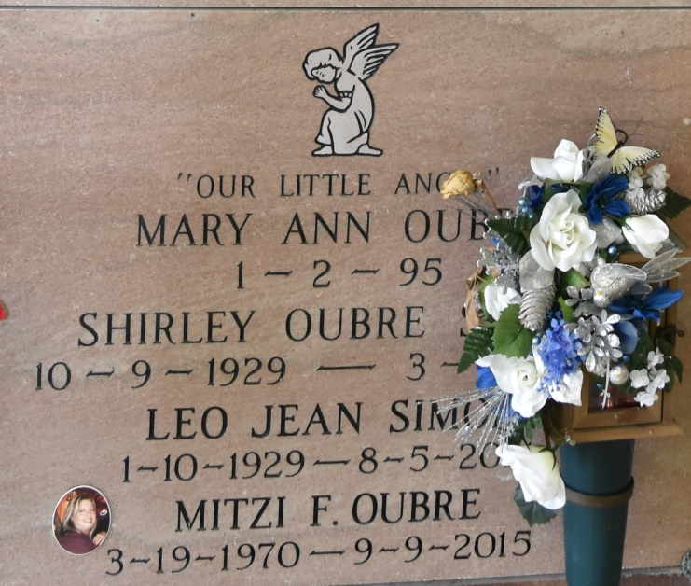

Mitzi Falgoust Oubre, 45, died on Wednesday, September 9, 2015. She is survived by one daughter and son-in-law, Britney and Shawn Schexnayder; one son, Cody Oubre; one grandchild, Raygen Schexnayder; mother, Cheryl Simon; father, Donald Falgoust; one sister and brother-in-law, Kristi and Heath Marse; one brother, Todd Falgoust; one nephew, Chase Ordoyne; three nieces, Kayla Falgoust, Rebecca Falgoust, and Karli Marse; and one Godchild, Lexi Marse. Preceded in death by one daughter, Mary Oubre; maternal grandparents, Leo and Shirley Simon; and paternal grandparents, Antoine and Thelma Falgoust. Visitation will be held on Tuesday, September 15, 2015 at 11:00 a.m. until Mass of Christian Burial at 2:00p.m. at Our Lady of Peace Catholic Church in Vacherie. Entombment to follow in church mausoleum. Arrangements by Ourso Funeral Home in Donaldsonville. To offer condolences to the family, please sign the online guestbook at www.oursodonaldsonville.com.

Ourso Funeral Home, Donaldsonville, LA