Ollie Mercedes (Steib) Oubre

July 10, 1902 – December 24, 1994

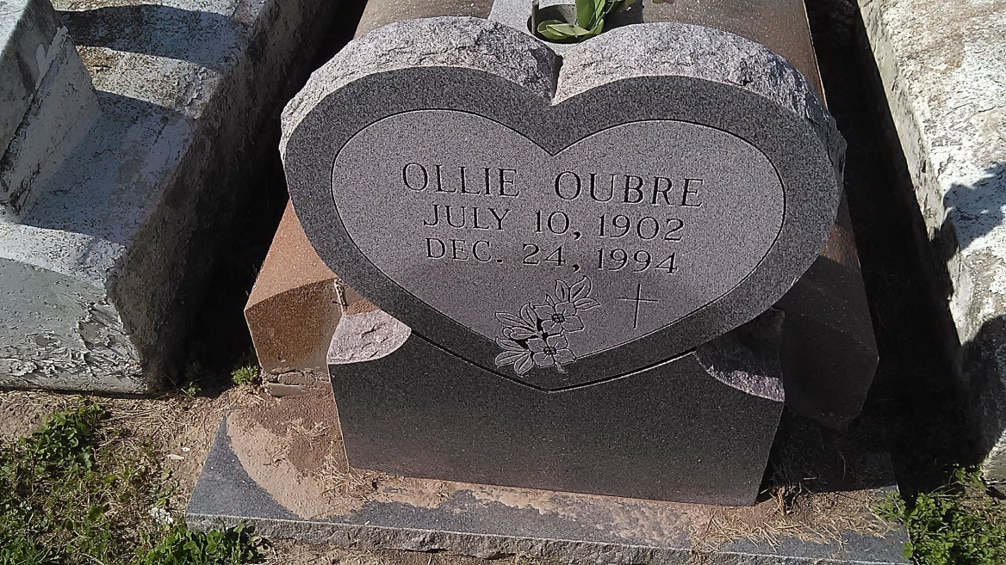

Photo by TMB

##### A Mass of Christian Burial will be celebrated at 10:30 a.m. Tuesday at Our Lady of Peace Catholic Church in Vacherie for Ollie Steib Oubre, 92, a native and resident of Vacherie, who died Saturday, Dec. 24, 1994. Visitation is from 8 a.m. until funeral time Tuesday at the church. Burial is in the church cemetery.

##### She is survived by her son, Floyd Oubre; daughters, Joyce O. Philips and Maxine Borne; brother, Lazard Steib; and several grandchildren and great-grandchildren. She was preceded in death by her husband, Walter J. Oubre Sr.; parents, Adler and Ursuline Dumas Steib; sons, Walter Jr., Paul and Donald Oubre; and daughters, Nelva Dumas and Ursuline Domino. Southall Westside Funeral Home in Vacherie is in charge of arrangements.

##### Unknown source