Raymond Joseph Oubre

January 5, 1950 – December 2, 2018

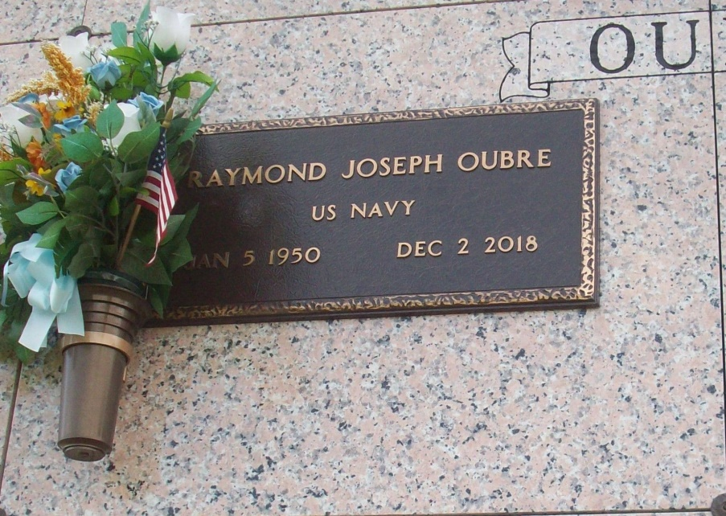

Photo by TMB

Raymond Joseph Oubre, 68, a native and resident of Vacherie, passed away peacefully at his residence Dec. 2, 2018.  
 Visitation will be held from 9:30 a.m. until a Mass of Christian Burial at 12 p.m. Saturday, December 8, at Our Lady of Peace Catholic Church, 13281 LA-644 in Vacherie. Entombment in Our Lady of Peace Mausoleum.  
 Raymond is survived by his devoted and loving wife, Bernadette W. Oubre; daughters, Renisha and Brittany Oubre; grandchildren, Logan and Natalie Oubre; brother, Freddie (Gloria) Oubre; brother-in-law, Oscar Pedescleaux Sr.; aunts, Catherine (Melvin) Francis, Doretha Keller, Fannie Philips and Marlene Oubre; and numerous other relatives and friends.  
 He was preceded in death by his parents, Freddie Sr. and Pauline P. Oubre; sister, Catherine Pedescleaux; and brother, Michael Oubre.  
 Arrangements are by Williams and Southall Funeral Home, 5414 La. 1, Napoleonville.

Courier, The (Houma, LA) - Friday, December 7, 2018