Florence (Favorite) Ovide

September 8, 1910 – August 27, 2002

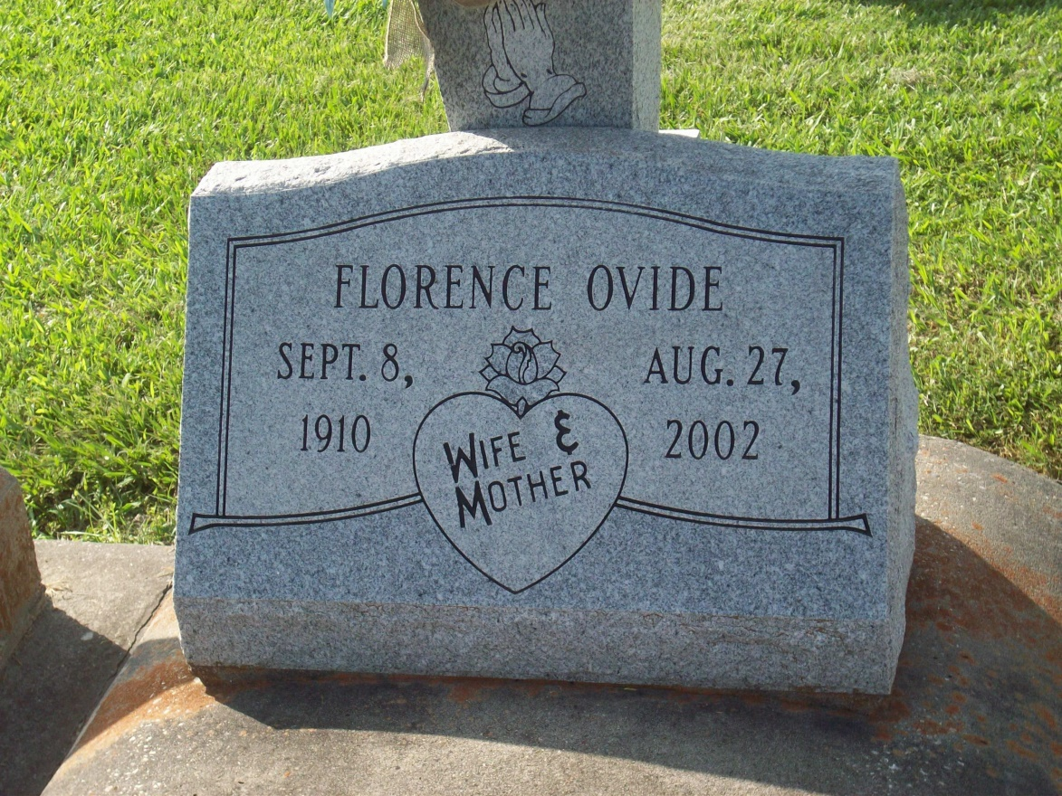

Photo by TMB

RESERVE - Florence Favorite Ovide, 91, a native of St. James and resident of Reserve for more than 50 years, died Aug. 27. She was the wife of Anthony Ovide Sr., mother of Edward Scioneaux Sr. and stepmother of Rita McBuffy, Ralph and Anthony Ovide Jr.  
  
She is also survived by 16 grandchildren and many great-grandchildren.  
  
Services were Sept. 2 at Our Lady of Grace Catholic Church, Reserve, with interment at Our Lady of Peace Cemetery, South Vacherie.

L'Observateur (La Place, LA) - Saturday, September 7, 2002