Tyra Alexis Pierce
December 3, 1998 – November 7, 2024

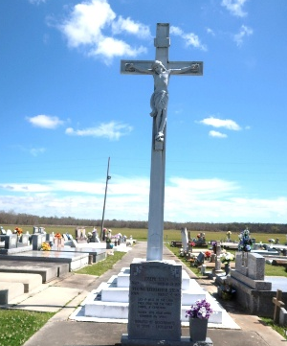

Tyra Alexis Pierce entered eternal rest on Thursday, November 7, 2024, at the age of 25 at St Elizabeth Hospital surrounded by family and friends. She was a native of Vacherie, LA and resident of Baton Rouge, LA. Tyra graduated from St. James High School in 2017 where she participated in JROTC and the AKA Ascend program. She also attended Southern University Baton Rouge, LA where she served on the student council and became a proud member of the Beta Psi Chapter of Alpha Kappa Alpha Sorority, Inc. Spring 2018. Tyra graduated from Arizona State University in May 2024.
Tyra was affectionately known as Tah or Toddy. She was formerly employed at Koch Methanol St. James and BASF Geismar as a laboratory technician. Tyra leaves to cherish her memories, her precious baby boy, Callyx Chambers; She was the beloved daughter of Dana and Randoll Rohilliard Sr. and Troy and Dimitri Pierce; 5 siblings: Asha Pierce, Troy Howard, Randoll Rohilliard Jr. Kristin Williams and Darius Brown; grandparents: Joseph Jules, Jr. and Dorothy Harry, Jessie Robertson, and Murphy Sr. and Marion Rohilliard; One nephew, Bryce Malancon; Aunts: Karen (Julius) Boudoin, Requelle (Bradford) Jones, Irma Pierce; Uncles: Steven (Gilda) Harry, Carey (Sabrina) Pierce, Joseph Robertson. Godmothers: Karen Boudoin and Irma Pierce; Godfather: Gregory Johnson; one godchild, Cali Noble; Devoted cousins, Kasia Harry, Ariana Boudoin, and Briana Boudoin; Devoted and lifelong friends, Jhai Small, Kenneth Nicholas Jr., Darius Scott, Trevon Frank, and Trey Gros; also survived by a host of other relatives and friends.
Tyra is preceded in death by her paternal grandfather, Aldin Pierce; her uncles, Aldin Pierce Jr. and Murphy Rohilliard Jr.
Relatives and friends of the family are invited to attend a public viewing at Treasures of Life Funeral Home 315 East Airline Highway, Gramercy, LA on Friday, November 15, 2024 from 6:00 pm to 8:00 pm. A Celebration of Life will be held at Mt. Calvary Baptist Church 8969 Highway 18 St. James, LA on Saturday, November 16, 2024 at 11:00 am. Visitation will begin at 9:00 am. Entombment: Our Lady of Peace Catholic Church cemetery.

Treasures of Life Center for Life Funeral Services, Gramercy, Louisiana
November 17, 2024

