Dolores (Himel) Poirrier

March 24, 1932 – March 15, 2005

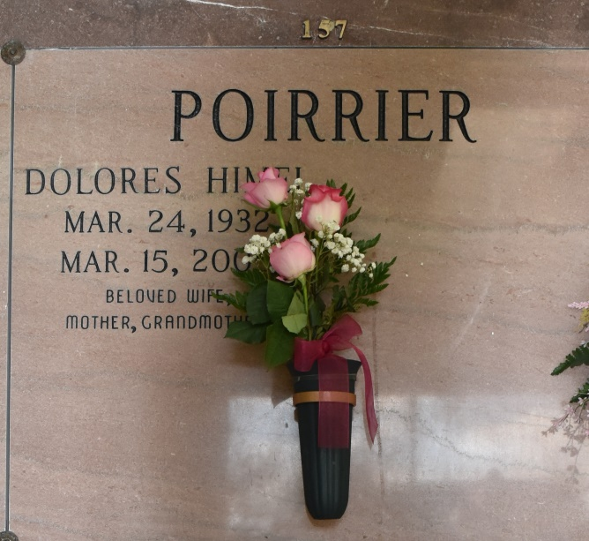

Dolores "Doe' Himel Poirrier, a life long resident of Vacherie, LA, age 72 years, born in Thibodaux, LA and died at her residence on Tuesday, March 15, 2005 at 1:30 a.m. from complications of a stroke.

Dolores is survived by: her beloved husband, Whitney J. Poirrier of 55 years; three daughters: Cheryl P. Radosta, Kay P. Matherne, Monique P. Magee; one grandson, Scott Whitney Radosta; one brother, Joseph Himel; three sisters: Bea H. Easley, Doris Aucoin and Gertrude H. Owens; and numerous nieces and nephews.

Preceded in death by her parents, Walter and Emma Clement Himel; two brothers: Edward and Norman Himel; and two sisters: Elva Chaisson and Anna Mae Raziano.

Visitation will be at St. Philip Catholic Church, Vacherie, LA on Thursday, March 17, 2005 from 8:00 a.m. to 1:00 p.m. Followed by a Mass of Christian Burial, officiated by Fr. Tom Hoffman, S.J. Interment at Our Lady of Peace Cemetery, Vacherie, LA. ROSE LYNN FUNERAL SERVICES is in charge of arrangements.

The Times-Picayune, New Orleans, LA

March 16, 2005