Doris Lucille Poirrier

October 22, 1922 - January 28, 2014

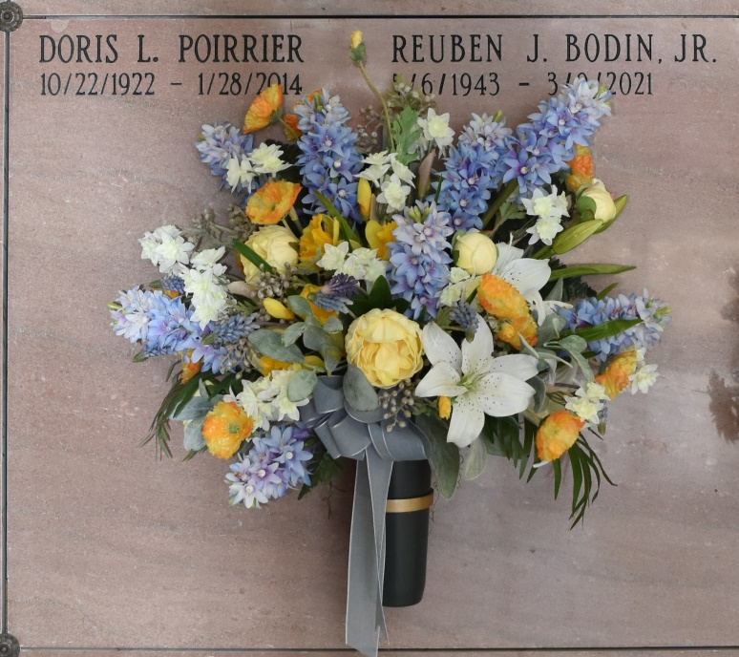

Doris L. Poirrier, 91, a native and resident of Vacherie, was born Oct. 22, 1922, and passed away Tuesday, Jan. 28, 2014.  
 Visitation will be from 9 a.m. until funeral time Saturday at St. Philip Catholic Church in Vacherie. A Mass of Christian burial will be at 11 a.m. Saturday at the church, with burial in Our Lady of Peace Cemetery in Vacherie.  
 She is survived by her brother, Whitney Poirrier; sister, Phyllis Bodin and husband, Reuben; sister-in-law, Jane Veillon Poirrier; and numerous nieces and nephews.  
 She was preceded in death by her parents, Jean Willis Poirrier and Frieda Falgoust Poirrier; sister, Adeline Poirrier Bright and husband, Elmer; sister-in-law, Dolores Himel Poirrier; and niece, Beth Bright Blount.  
 She was a graduate of Loyola University and retired as a medical technician.  
 Rose Lynn Funeral Home in Lutcher is in charge of arrangements.

Houma Today, Terrebonne Parish, LA

February 6-7, 2014