Audrey (Ockmond) Reulet

December 13, 1927 – October 22, 2020

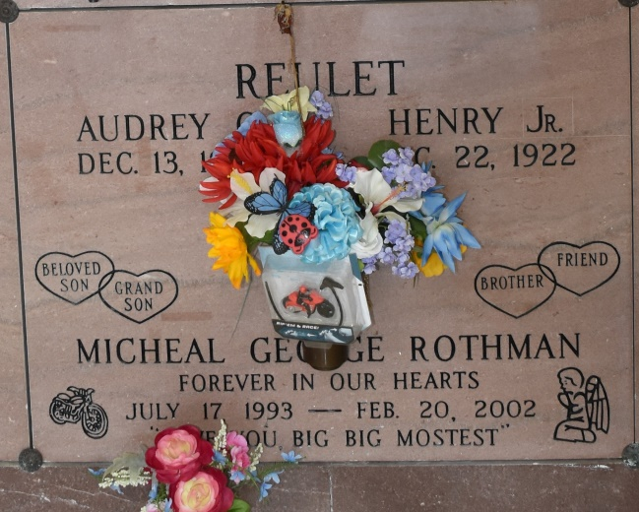

Audrey Reulet, 92, a native and resident of Vacherie, Louisiana and passed away on Thursday, October 22, 2020.  
 A wake will be held at Thibodaux Funeral Home 8am - 10:30am, with a church mass and burial to follow at Our Lady of Peace Catholic Church in Vacherie at 11am on Wednesday, October 28, 2020.  
 She is survived by her daughter, Monica Reulet; grandson, Brad Rothman; granddaughter, Brandi Rothman; great-granddaughters, Cerridwen Rothman, Mia Rothman, & Henrietta Rothman; and great-grandson, Jamiah Walker.  
 She was preceded in death by her husband, John Reulet, Jr.; father, Joseph Ockmond; mother, Odile Chenier Ockmond; and grandson, Michael George Rothman.  
 Audrey was born and raised in Vacherie, Lousiana and a proud member of the Catholic Daughters. Audrey also enjoyed attending the Vacherie Senior Center and spending time talking to her friends. "Maw" as she was called by most of her family, was the most kind-hearted mother and grandmother anyone could ask for. She spoiled everyone who stepped foot in her home. She was blessed with many years and her family is incredibly grateful to have had all the time they had with her. She will be greatly missed by all who knew her.  
 Online condolences can be given at [www.thibodauxfuneralhome.com](http://www.thibodauxfuneralhome.com/)  
Thibodaux Funeral Home, Inc. is in charge of arrangements

Houma Today, Terrebonne Parish, Louisiana

Oct. 26 to Oct. 27, 2020