David Lloyd Reulet
February 2, 1957 - May 11, 2025

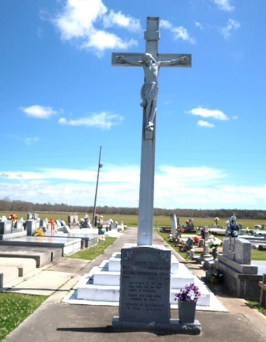

David “Bim” Lloyd Reulet, lifelong resident of Vacherie, Louisiana, passed away peacefully on the morning of May 11, 2025—Mother's Day—at the age of 68.
Born on February 2, 1957, Bim spent his life in the town he loved, surrounded by the people who loved him. Known for his larger-than-life personality and infectious laugh, Bim never met a stranger. He had a natural gift for bringing joy to those around him and was happiest when surrounded by family, friends, and a good story.
A man of many talents, Bim was most at home with his hands busy-working on trucks, tractors, or just about anything mechanical. His energy and enthusiasm were unmatched, and he was always quick to lend a hand or share a laugh.
Bim is survived by his daughter Michelle Reulet; his cherished grandson Carter Myers, who was the light of his eyes; his mother, Belle Reulet, with whom he shared a deep bond of love respect and protection; his sisters Angele Rodrigue (Vernon), Patricia Gravios (Blaise), Rachel Rome (Lonny), Margaret Cortez (Scott); brother-in-law, Todd Marse (Stephanie) and his sister-in-law Rhonda Folse. Bim also leaves behind his loving companion, Suzanne Dempster.
Bim was preceded in death by his beloved wife, Cheryl Marse Reulet, who passed in 2016; his father Lloyd Joseph “Bim” Reulet; his brothers, Michael, Randy, Lynn and Kenneth Reulet.
Bim’s legacy is one of laughter, loyalty, and love. His absence leaves a void that can never be filled, but his spirit will remain with all who were lucky enough to know him.
Relatives and friends are invited to attend the Visitation and Funeral at Our Lady of Peace Catholic Church, 13281 LA-644, South Vacherie, LA 70090 on Thursday May 15, 2025. Visitation at church from 10:30 a.m.-11:00 a.m. followed by a Funeral Mass at 11:00 a.m. Interment will take place after the Funeral Mass in Our Lady of Peace Catholic Cemetery.

Rose Lynn Funeral Home, Lutcher, Louisiana
May 13, 2025

