Kirk P. “Jo” Reulet

July 8, 1949 – January 2, 2019

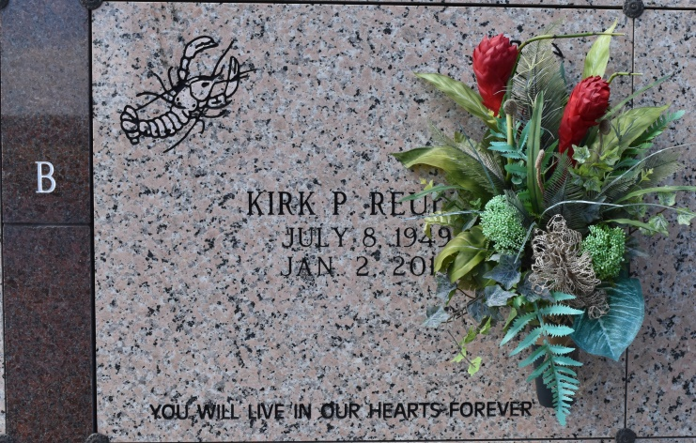

(Jo) Kirk Reulet, 69, a native and resident of Vacherie, LA passed away on Wednesday, January 2, 2019.   
 He is survived by his devoted wife Joann Clement Reulet of 44 years; children, Leslie (Kyle) Carrere and Evan Reulet (fiancée Tanya); and grandchildren, Faith, Carson, Hayden, and Van Reulet, and Layla Price. Kirk was blessed with a large family of which he leaves behind, his mother, Marie Lois Reulet; six sisters and one brother as well as a host of aunts, uncles, nephews and nieces.  
 He was preceded in death by his father, Pierre H. Reulet; in-laws, Edward and Anna Clement, Sr.; brothers -in- law, Edward Clement, Jr. and Boyd Mahler; nephew, Matt Mahler; paternal grandparents, Mr. and Mrs. Charles Reulet; and maternal grandparents, Mr. and Mrs. Garfield Falgoust.  
 Kirk retired from Carpenter Local 1846. His time after that was spent with his grandchildren fishing, crabbing, dirt bikes, and sports. He treasured every minute that he could spend with everyone that touched his life especially his "adopted" grandchildren. He was able to continue his passion of building homes within the community for family and friends. Jo Kirk will always be remembered for his kind heart, willingness to help anyone and his ability to make everyone laugh and enjoy being called a friend.   
 We would like to thank everyone who have sent their prayers, condolences, and supported us through this journey. You will always be in our hearts. Thanks to M. D. Anderson Hospital and the Care Team for the exceptional care and support given to Kirk. Special thanks to our family, for with you we are united and comforted. God bless everyone. As Kirk would say when he ended every conversation; "Later". Kirk we will be together again later!  
 Interment at Our Lady of Peace Catholic Church Mausoleum. Thibodaux Funeral Home, Inc. is in charge of arrangements.

Thibodaux Funeral Home, Thibodaux, LA