Pierre Helton Reulet

September 25, 1925 – October 24, 2014

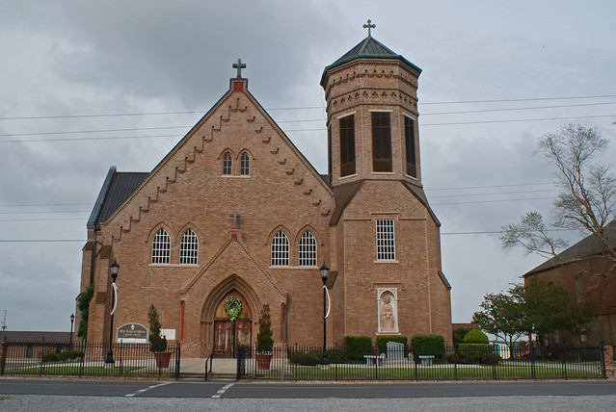

Pierre Helton Reulet, 91, a native and resident of Vacherie, LA passed away on Monday, October 24, 2016. Visitation will be held on Saturday, October 29, 2016 Our Lady of Peace Catholic Church in Vacherie, LA from 8:00 a.m. until Mass of Christian Burial at 11:00 a.m. officiated by Fr. Reuben Dykes. Entombment to follow in Church Mausoleum.  
 He is survived by his wife of 69 years, Lois Falgoust Reulet; children, Kirk (Joann) Reulet, Sheila (Francis "Butsy") Becnel, Pam (Wayne "Green") Kliebert, Arlene (Wendell "Duke"), Ockmond, Myron (Anne) Reulet, Rachel (Perry) Perque, Lola (the late Boyd) Mahler, and Tammie (Mark "Pott") Aubert; grandchildren, great-grandchildren, and one sister, Verline Reulet Borne.  
 Preceded in death by his parents, Charles and Elise Steib Reulet, grandson Matthew Joseph Mahler; great-grandson, Drake Michael Kliebert; son-in-law, Boyd Anthony Mahler; brothers, Herbet, Herman and Charles Reulet; sisters, Cecilia Reulet, Azema Folse, and Elaine Schexnayder.  
 Pierre served as a veteran in the US Army, member of the VFW Post 4245, he was a carpenter, and he retired from Avondale Shipyard.  
  
Published in Houma Today & The Daily Comet, Terrebonne Parish, LA from Oct. 26 to Oct. 27, 2016