Therese (Becnel) Reulet

October 15, 1927 – January 11, 2022

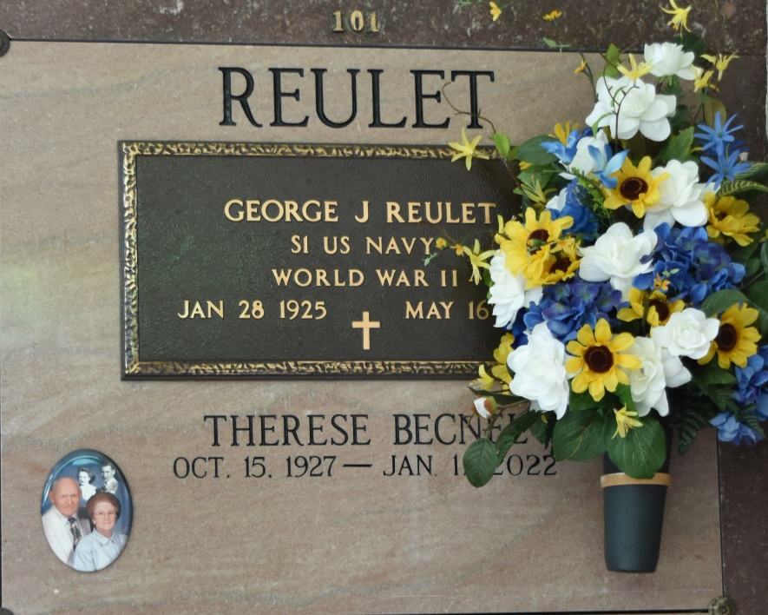

Vacherie - Therese Becnel Reulet, 94, a native of Vacherie, Louisiana and resident of Vacherie, Louisiana passed away on January 11, 2022.

A visitation will be held in her honor on January 17, 2022 at Our Lady of Peace in Vacherie Louisiana, from 9:30 am until the Mass of Christian Burial at 12:00 pm. The burial will follow in Our Lady of Peace Cemetery.

She is survived by her Children ; Samuel Jude (Ruth) Reulet, Geneva (Tommy) Breaux, Georgine (Joey) Fonseca, Dale Reulet, Meta R. Ordoyne, Merritte (Mary) Reulet, Martin (Tiffany) Reulet, Rene Reulet, Lynn (Angie) Reulet, 19 Grandchildren, 33 Great grandchildren and 7 Great great grandchildren, Sister in laws; Agnes Becnel, Clara Mae Becnel, Brother in law; Richard Reulet Sr. .

She was preceded in death by her loving husband George, Son in law Mark Ordoyne Sr., Daughter in law Maxine Reulet, Great grand-daughter Candace Reulet, Sister; Cecile Amedee, Brothers; Stanley, Roy, Henry, Gaston and Guy Becnel.

Therese was a retiree of St. James Parish school system. Her hobbies were playing Scrabble, gardening and ministering to others by writing inspirational notes and cards to others.

The family would like to express sincere thanks to her devoted care givers Thalia Ordoyne and Denise Amedee, hair dresser Snoopy, St.Joseph Hospice staff, her faithful prayer group, friends, family and community who took their time to visit and pray with her to the end.

Online condolences can be given at [www.thibodauxfuneralhome.com](https://www.thibodauxfuneralhome.com/)

Thibodaux Funeral Home, Inc. is in charge of arrangements.

Houmatoday.com

Posted online on January 13, 2022