Samuel Anthony Robinson Sr.

April 17, 1924 – November 21, 2019

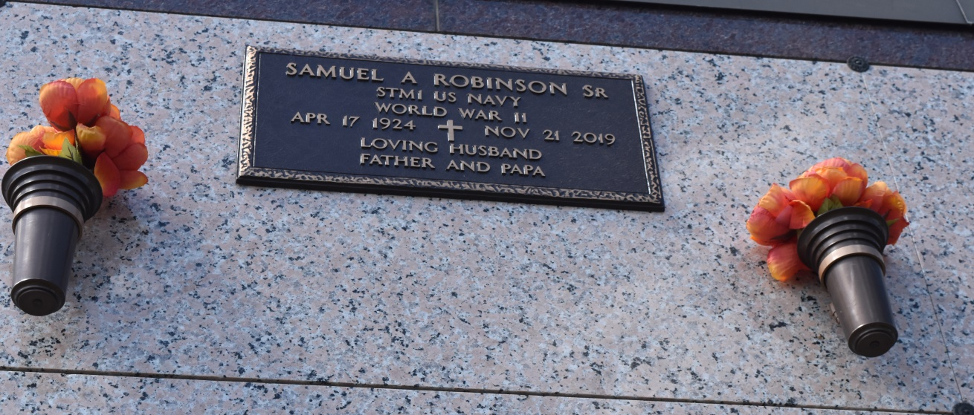

Samuel Anthony Robinson was born to Iona Jefferson and Evangelis “Van” Robinson on April 17, 1924 in Mobile, AL. He was the seventh of nine children.  
 Sam enlisted in the US Navy in 1943 during WWII. He received an honorable discharge from the US Navy and Coast Guard in 1946. Sam moved to New Orleans, where he met the love of his life, Margaret Dumas, whom he married September 1948.  
 Sam was an employee of National Gypsum Corporation and also worked as a gardener. After leaving National Gypsum he drove a taxi in the city of New Orleans.  
 For many years Sam was an usher at St. Theresa Catholic Church, a member of the Original Dukes Social and Pleasure Club, and a member of a bowling team. These memberships kept him very active. When he finally retired, he joined a senior center where he enjoyed spending time socializing and playing dominoes. Most recently he was a member of the Hollygrove Multipurpose Senior Center, where he received a 2016 Man of Wisdom Award. Prior to that he attended the Central City Senior Center where he was a member of the 2010 Royal Court and 2012 King of the Central City EOC Mardi Gras Ball. In 2013 he received a New Orleans City Council Proclamation for his reign as King.  
 On Thursday, November 21, 2019, Sam passed away peacefully at the age of 95. He was preceded in death by his parents Iona and Van; his sisters Naomi, Victorine and Josephine; his brothers Herman, Dennis and James; and wife Margaret.  
 Sam is survived by his sisters Francis Murphy and Edna Blake (James); daughter Gaynell McCurn (Robert); son Samuel Jr. (Lisa), granddaughter Keidra Armstrong, and grandson Jordan Robinson; along with a host of nieces, nephews, relatives and friends.  
 Relatives and friends of the family are invited to attend the following:  
Visitation - Monday, December 2, 1:30 PM to 3:30 PM, Rhodes Funeral Home, 3933 Washington Ave., New Orleans, LA 70125. Funeral Mass of Christian Burial - Tuesday, December 3 at Our Lady of Peace Catholic Church & Cemetery, 13281 LA-644, Vacherie, LA 70090. Visitation and rosary from 9:00 AM to 11:00 AM followed by Mass and internment. Internment: Our Lady of Peach Catholic Cemetery (same location as church)  
 Arrangements by D.W. Rhodes Funeral Home, 3933 Washington Ave., New Orleans LA.  
  
Unknown source