Marie (Oubre) Rodrigue

1911 – August 27, 1980

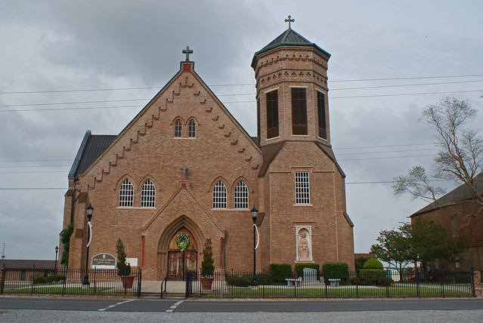

Marie Oubre Rodrigue, 69, a native and resident of Vacherie, died 1:40 p.m.   
Wednesday.   
  
Visitation will be until 10 p.m. today at Our Lady of Peace Church Hall in   
Vacherie, resuming 8 a.m. Friday and continuing until funeral time. The funeral will be 9:45 a.m. Friday from the church hall with religious services following 10 a.m. at Our Lady of Peace Catholic Church. Burial will be in the church cemetery.  
  
Survivors include her husband, Malkior Rodrigue; four sons, Chester, Mack, James and Manuel Rodrigue; two daughters, Mrs. Judy Ordoyne and Mrs. Virgie Loup; a brother, Willis Oubre; two sisters, Mrs. Marie Lassere and Mrs. Odile Falgoust; 22 grandchildren and 9 great-grandchildren.  
  
She is preceded in death by a son, Merlin Rodrigue; a brother, Pierre Oubre; and two sisters, Alice Smith and Felicity Reulett.   
  
Thibodaux Funeral Home, Thibodaux, is handling arrangements.

Houma Courier, Terrebonne Parish, LA; Thursday, August 28, 1980