E. J. Joseph Rose

June 5, 1941 – March 11, 2018

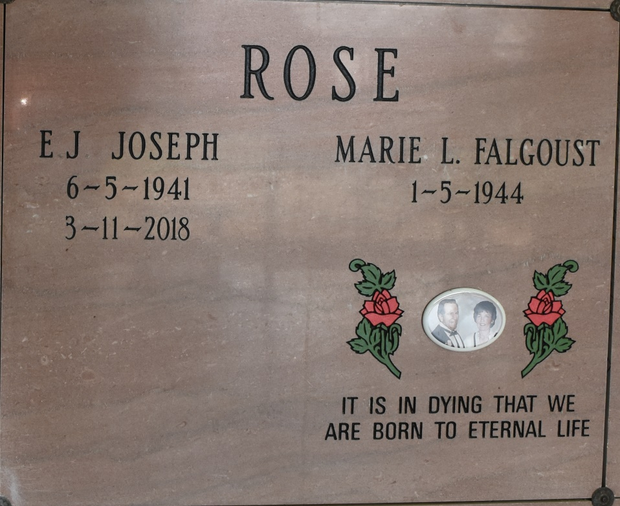

E.J. Joseph Rose departed this life at age 76 on March 11, 2018 peacefully at his home. He was born June 5, 1941 and was a native of Chackbay, LA and a resident of Vacherie, LA. He is survived by his loving wife, Marie Louise Falgoust Rose; his children, Eddie Rose and wife, Melissa; Ronnie Rose and wife Greta; Janet Hebert and husband, Lance; and Philip P. Rose; five grandchildren; one great-grandchild. He was preceded in death by his parents, Wilbert Rose and Eugenie Legendre; and brother, Norvin Rose. Visitation was held at Our Lady of Peace Catholic Church, Vacherie, LA on Saturday, March 17 , 2018 beginning at 10:00 a.m. until a mass of Christian Burial at 12:00 p.m. Entombment was in the mausoleum in the church cemetery. Online condolences can be given at www.thibodauxfuneralhome.com. Thibodaux Funeral Home, Inc. was in charge of arrangements.

News Examiner-Enterprise, St. James Parish, Louisiana

Thursday, March 22, 2018