Rev. Danny Jude Roussel

April 18, 1972 – August 30, 2021

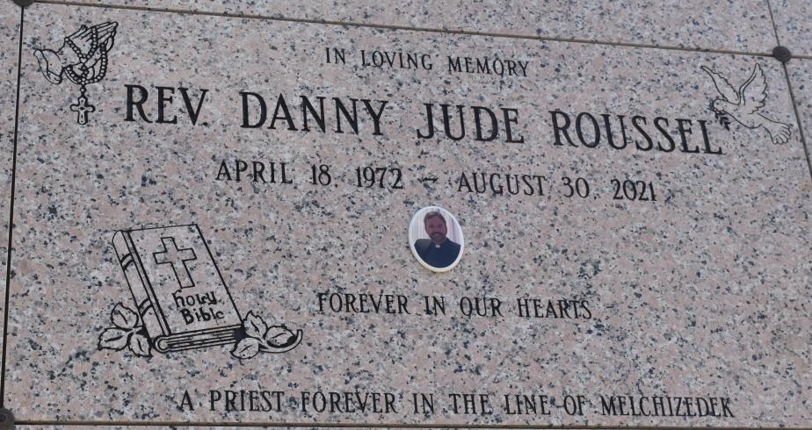

Father Danny Jude Roussel, a Catholic priest of the Diocese of Baton Rouge, died Monday, August 30, 2021, in Vacherie, LA.

He is survived by his loving and devoted mother, Judith (Judy) Roussel Bourgeois of Vacherie; stepfather, Ronald Bourgeois Sr.; brother, Audie Roussel; sister-in-law, Niomi Roussel; nephew, Collin Roussel; niece, Lindsey Roussel, and her son, Kohen Seiffert.

He was preceded in death by his father, Artidore “Pal” Roussel, his maternal grandparents, Lloyd and Cleophine Becnel Clement, and paternal grandparents, Rome’ and Marjorie Gaspard Roussel.

Danny was employed with Pepsi Bottling plant as a Quality Control Manager for 17 years.  It wasn’t until the plant closed that he found his true joy and made the decision to start his journey into priesthood.  For years, he volunteered at his home church parish of Our Lady of Peace in Vacherie, LA.  In 2014, he started his seminary formation and studied for seven years at Notre Dame Seminary in New Orleans, LA. He was ordained a priest into the Diocese of Baton Rouge on May 22, 2021.  Father Roussel was serving as parochial vicar at St. Aloysius parish in Baton Rouge, LA, and as a Chaplain to St. Joseph’s Academy.  He was also an 8-year member of the Knights of Columbus.  Danny was loved by his family and parishioners and will always be remembered for his devotion and commitment to his faith.

Private funeral services were held Friday for immediate family and a few intimate friends. His body is now at rest at Our Lady of Peace Cemetery in Vacherie, LA. A community celebration of Father Danny’s life will be held at a later date when our area recovers from storm damages and electrical power is restored.

While Father Danny was ordained for a very short time, his joy and faithfulness touched many lives and hearts. His family looks forward to hearing some of those stories at his forthcoming celebration. Until then, please continue to pray for all whom Father Danny ministered to and with, especially his family. Thank you for respecting the wishes of his family at this time. May God bless you all.

Rose Lynn Funeral Home

Lutcher, Louisiana