Reginald Roussell
April 7, 1959 - June 5, 2025

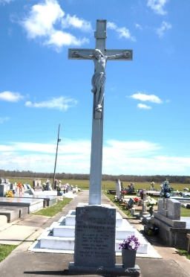

Affectionately known by his family and friends as “Recker” transitioned to his eternal home on June 5, 2025 at his residence in Vacherie, La. at the age of 66. Reginald was born on April 7, 1959 at Charity Hospital in New Orleans, La. to Melvin John Roussell and Florence D. Roussell. A 1979 graduate of St. James High, he entered the industrial workforce shortly after graduation, where he built a lifelong career marked by dedication, skill, and resilience.
Outside of work, Reginald was a devoted father, husband, brother, uncle, and friend. On October 19, 1991, Reginald married Acquanette James, and to this union one child was born Chaz Alexander James Roussell. Reginald enjoyed life’s simple pleasures like fishing, barbecuing, drawing, and playing music, at which he was very gifted. He loved sports, took pride in cleaning his vehicles, and found peace in cutting grass. Most of all, he cherished spending time with his family and talking with people. His warmth and presence made others feel at ease, and his spirit lives on through the many lives he touched.
A man of quiet faith, Reginald found strength and comfort in the Lord. His presence in the community was steady, humble, and kind. He was truly a man who left a mark on everyone he met. He leaves behind a legacy of love and hopefulness that will remain.
He leaves to cherish his memory: His loving wife, Acquanette James Roussell; his son, Chaz Alexander James Roussell (Raven). He is also survived by his mother, Florence D. Roussell; two brothers: Anthony Roussell Sr. (Maxine) and Danny Roussell; three sisters: Valerie R. Whittington (Edwin), Sharon R. Steib (Nicholas), and Veronica R. Webre (Raleigh, Sr.); sister-in-law, Renda Roussell; four uncles: Alvin Sr., Warren, and Mervin Roussell, Steve and Larry Malancon; four aunts: Josephine, Rita, Debra, and Verlyn Malancon. Those left to cherish his legacy include Clairrita (Leonard) Raphael, Joelle (Henry Adams) James, Fredricka (Harry) Calloway, Christine (Norris) Washington, Eva (Howard) Irving, Troy (Connie) Dumas, Sunniva James (Paul Gautreau), Cristy James, Patrice Dumas, April Dumas, Rosalind Mitchell and Anthony Smith. Among those who continue to honor his memory forward are a host of nieces, nephews, and all those whose lives he touched with his kindness and strength.
Reginald is preceded in death by his father, Melvin J. Roussell; two uncles: Melvin Roussell, Jr. and Allen J. Roussell, father & mother in laws; Joseph James, Eva Dumas, Celeste James and sister in law Paulette J. Smith.
A Mass of Christian Burial will be held on Saturday, June 14, 2025 at Our Lady of Peace Catholic Church, 13281 LA-644, South Vacherie, LA 70090 for 1:30 p.m.; visitation is from 11:00 a.m. to 1:30 p.m. Interment to follow at Our Lady of Peace Catholic Church Cemetery.

Treasures of Life Funeral Services, Gramercy, Louisiana
June 13, 2025

