Louis Saul
June 28, 1949 - July 3, 2025

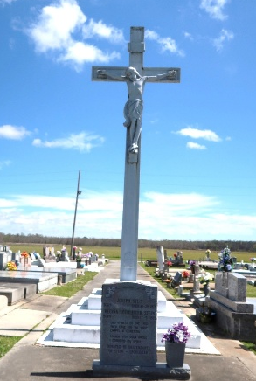

Louis Saul, a native of Vacherie and a resident of Wallace, passed away on July 3, 2025, at the age of 76. He is survived by his wife, Elma Jean Cutno-Saul, of 47 years; 3 daughters, Kerry (Don) Rainey, LaCheta (Brian) Saul-Alexander, and Jarren Saul; 2 sons, Donnell Saul, and Anthony (Francine) Saul; 13 grandchildren; 1 great-grandchild; 1 brother, Donald (Emelda) Saul; 2 sisters, Cheryl (Curtis) Williams and Carmel Saul; a host of brothers- and sisters-in-law; 2 bonus children, Anissa Saul and Michael Allen; a host of nieces, nephews, cousins, and friends.
He is preceded in death by his parents, Harry and Leola Saul; brothers, Preston, Walter, and Larry Saul; sister, Paula Kelly; 3 sisters-in-law; and nephew/Godchild, Dramar Saul.
A Gathering of Family and Friends will be held Friday, July 11, 2025, at Treasures of Life Funeral Services, 315 E. Airline Hwy., Gramercy, LA 70052 from 3pm to 5pm. Funeral services will be Saturday, July 12, 2025 at Treasures of Life Funeral Services, 315 E. Airline Hwy., Gramercy, LA 70052, for 11am; visitation is from 9am to 11 am. Entombment, Our Lady of Peace Catholic Church Mausoleum, 13281 LA 644, Vacherie, LA. Repass: Our Lady of Peace Catholic Church Offertory, 13281 LA 644, Vacherie, LA.

Treasures of Life Funeral Services, Gramercy, Louisiana
July 13, 2025

