Marie (Brazan) Schexnayder

June 16, 1905 – November 16, 1991

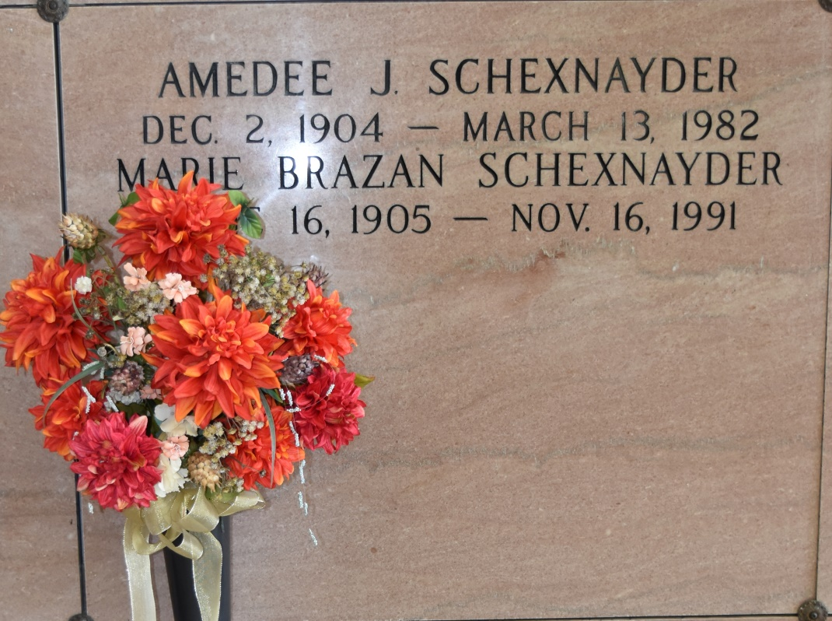

A religious service was held today at Our Lady of Peace Catholic Church in Vacherie for Marie Brazan Schexnayder, 86, a native and resident of Vacherie who died Saturday. Interment was in the church cemetery.

She was the mother of Carl Schexnayder of Harahan and Mrs. Marion Bruno of New Orleans. She is also survived by nine grandchildren and 19 great-grandchildren. She was preceded in death by her husband, Amedee Schexnayder. Landry's Funeral Home of Thibodaux was in charge of arrangements.

Unknown source  
Contributed by rrcar