Hazel Faye (Armant) Scott

January 5, 1954 – August 1, 2019

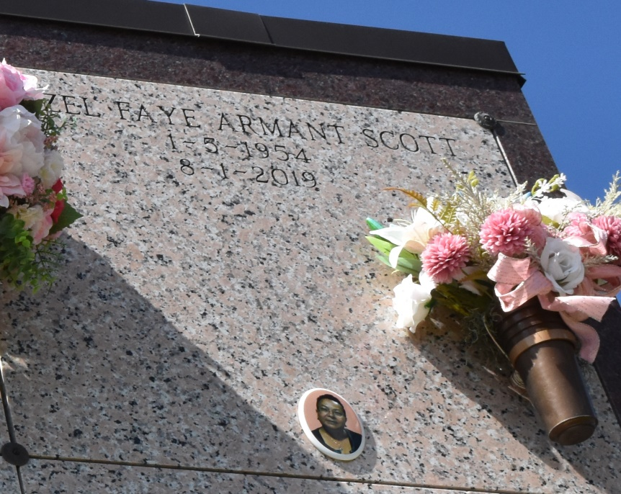

Hazel Scott, 65, Omega, Thursday, August 1, 2019 at Ochsner Medical Center in Jefferson, LA. Hazel was born January 5, 1954, in Vacherie, LA and was a resident of LaPlace, LA. She was a graduate of St. James High School Class of 1972 and attended Nicholls State University. She was a retired retail manager. She enjoyed spoiling her beloved pet dog, Pepper, traveling, casinos, sewing, baking and cooking. She is survived by her husband, Frederick Scott; sons, Derick Williams and Jamar Williams; stepson, Jermond Love; grandchildren, Dominique Williams, Jamya Williams, Kennika Love and Kajayla Williams; god-children, Tevin Philip and Marc Vinning; siblings, Ella Philip, Lana Philip, Vernonica Zenon, Phillis Clay, Marie Growe; in-laws, Barbara Butler, Ann Scott Sterling (Leon) Betty Johnson (Roderick), Martha Ann Romulus (Juan) Marbra Rixner (Clay), Marie Scott, and Edward Scott (Larissa); and a host of many family and friends. Hazel is preceded in death by her parents, Dory R. Philip and Eddie Armant; son, RaShad Williams; stepson, Kendrick Love; step-father, Joseph E. Philip; siblings; Sidell and Lawrence Armant; and sister-in-law, Catherine Esko. Mass of Christian Burial will be held on Saturday, August 9, 2019 at Our Lady of Peace Catholic Church, 13281 Hwy. 644, Vacherie, LA, 70090. Visitation begins at 9:00 a.m. followed by Rosary at 9:30 a.m., followed by Class of 1972 presentation, service at 11 a.m. Entombment at Our Lady of Peace Church Cemetery. Final care has been entrusted to Treasures of Life Funeral Services, 315 E. Airline Hwy Gramercy, LA 70052.

Treasures of Life Funeral Services, Gramercy, Louisiana