Percy Jimmy Scott

July 6, 1935 – September 26, 1994

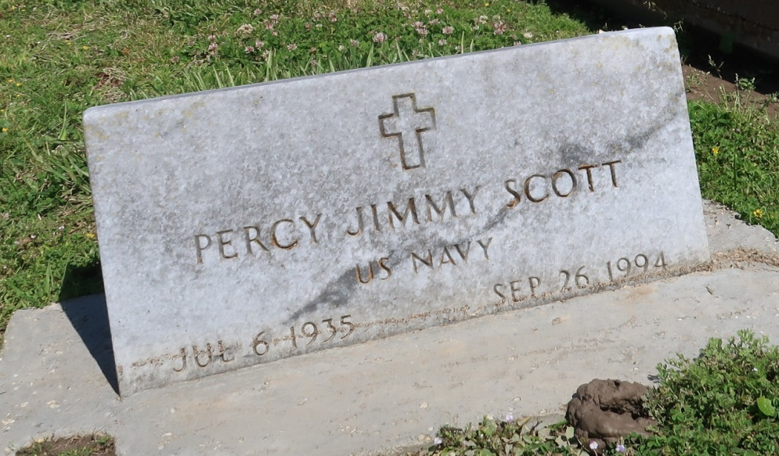

A Mass of Christian burial was celebrated at 10 a.m. today at Our Lady of Peace Catholic Church in Vacherie for Percy Jimmy Scott, 59, a native of Vacherie and resident of Chackbay, who died at 3:15 a.m. Monday, Sept. 26.1994  
  
He was the husband of Shirley W. Scott; father of Angela Scott of Thibodaux,  
Cynthia Melancon of Vacherie, Juanita Parquet of River Ridge, Casandra Comery of Donaldsonville and Percy J. Scott Jr. of Stone Mountain, Ga.; stepfather of Cathy Burrell of Chackbay and Carolis Wood of Thibodaux. He is also survived by 10 grandchildren.  
  
He was preceded in death by his first wife, Essie Marie Scott; parents,  
Josephine and Percy Scott.  
  
Southall-Westside Funeral Home was in charge of arrangements.

Unknown source