Maude M. Simon

April 12, 1924 – October 10, 2019

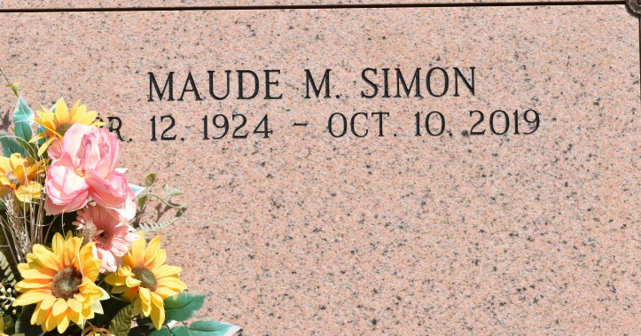

Maude Simon, born on April 12, 1924, a native of Vacherie, Louisiana and resident of Jefferson, Louisiana, passed away on Thursday, October 10, 2019 at the age of 95, surrounded by loved ones. A visitation will be held in her honor on Tuesday, October 15, 2019, at Our Lady of Peace Catholic Church in Vacherie, Louisiana from 9:00am until the Mass of Christian Burial at 11:00am, with a rosary at 9:30am. The burial will follow at Our Lady of Peace Cemetery in Vacherie, Louisiana. She is survived by her sisters, Alice Falgoust and Herminie Brack; and numerous nieces and nephews. She was preceded in death by her parents, Hermenegilde and Georgine Simon; sisters, Claire Rodrigue and Lois Chenier; and brothers, Albert Simon and baby Megilde Simon. She moved to Jefferson, Louisiana in 1945 and began working at Rheems Manufacturing until her retirement in 1979. After that, she worked for Maison Blanche. She was a devout and faithful Catholic and lived her faith to the greatest ability. She loved the Mass and praying the rosary for all her family and friends. Even though she never married and had no children of her own, she left a host of nieces and nephews who will miss her so much. She touched all their lives. Online condolences can be given at www.thibodauxfuneralhome.com Thibodaux Funeral Home, Inc. is in charge of arrangements.

The Times-Picayune, New Orleans, Louisiana

Oct. 13, 2019