May Cecile (Labat) Simon

January 24, 1927 – May 19, 2004

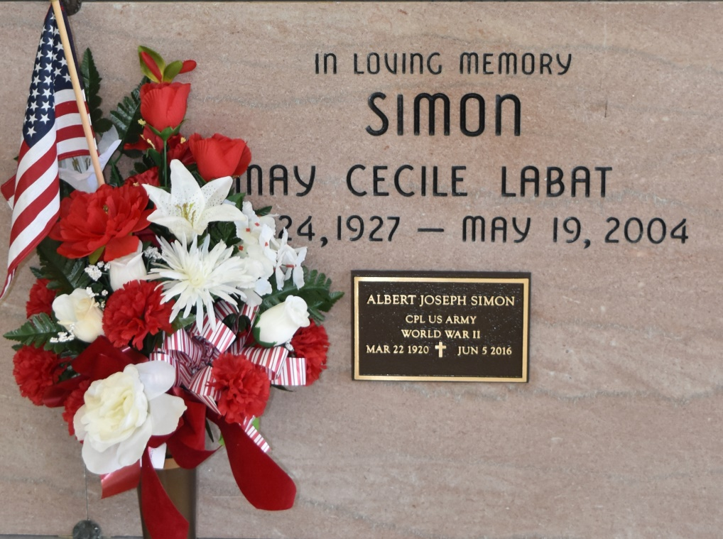

May Labat Simon passed away on Wednesday May 19, 2004 at 12:19 P.M. Survived by husband Albert J. Simon. Sons Reggie and Myra Falgoust Simon; Mark and Connie Breaud Simon from Thibodaux, LA; daughters Annie and Brian Falgoust and Selma Simon. Brothers Dudley Labat of St. James, LA and Lester Labat of Chalmette, LA. Mrs. Simon is survived by 7 grandchildren. Preceded in death by her parents Richard and Selma Labat; brothers Rumsey, Sidney, Ikay, Ray and Claude Labat and sister Mary Alice Becnel. Mrs. Simon was 77 years old, a native and resident of Vacherie, LA. A loving and devoted wife, mother and grandmother. Member of Our Lady of Peace Altar Society, CDA Court Notre Dame dela Paix and a committed Adorer at Our Lady of Peace Eucharistic Adoration Chapel. Relatives and friends of the family are invited to attend the Mass of Christian Burial Friday May 21, 2004 at 12 Noon at Our Lady of Peace Catholic Church in Vacherie, LA. Visitation Friday May 21, 2004 from 8:00 AM until Funeral Time. Burial in Our Lady of Peace Catholic Cemetery, Vacherie, LA. LANDRY'S FUNERAL HOME, INC. in charge of arrangements.

Times-Picayune, The (New Orleans, LA)

Friday, May 21, 2004  
Contributed by Jane Edson