Shirley Mae (Oubre) Simon

October 9, 1929 – March 9, 2011

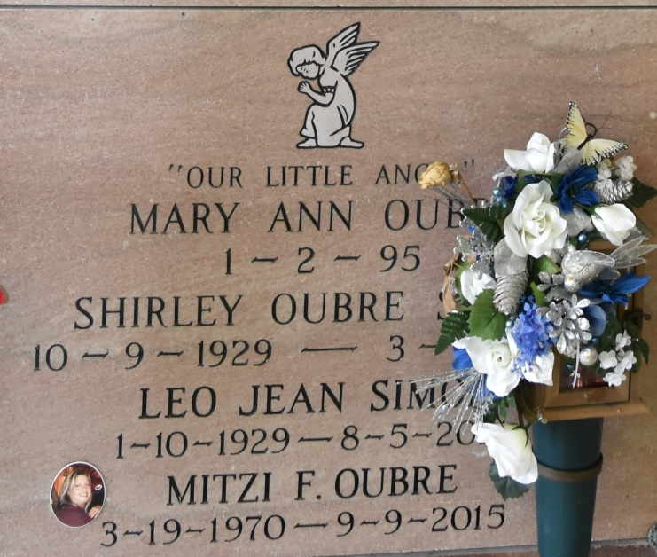

Shirley Mae Oubre Simon, 81, a native and resident of Vacherie, entered eternal life on Wednesday, March 9, 2011. A loving wife, mother, grandmother and great-grandmother, she was a devoted homemaker and avid cook who enjoyed preparing Sunday dinners for her family. Visitation at Our Lady Peace Catholic Church in Vacherie on Friday, March 11, from 9 a.m. until a funeral Mass at 11 a.m. Entombment at a later date in the church mausoleum. She is survived by her beloved husband of 63 years, Leo Simon; daughter, Cheryl Simon; three grandchildren, Todd Falgoust, Mitzi F. and husband Peter Oubre, and Kristi F. and husband Heath Marse; and seven great-grandchildren, Kayla Falgoust, Rebecca Falgoust, Chase Ordoyne, Britney O. and husband Shawn Shexnayder, Cody Oubre, Lexi Marse, and Karli Marse. She is also survived by a brother, Roland Oubre. She was preceded in death by her parents, Therance and Clothilde Rome Oubre; son, Lonny Jean Simon; and great-granddaughter, Mary Oubre. She was also preceded in death by her sisters, Maria Oubre, Celie Chenier, Mildred O. Landry, Gladys O. Becnel and Dolores O. Ockmond; and brothers, Calvin, Lawrence, Hernest and Clamce Oubre. Please sign the online guestbook at [www.oursodonaldsonville.com](http://www.oursodonaldsonville.com/).

The Advocate, Baton Rouge, Louisiana

March 10, 2011