William Simon, Jr.

October 29, 1929 – December 27, 2001

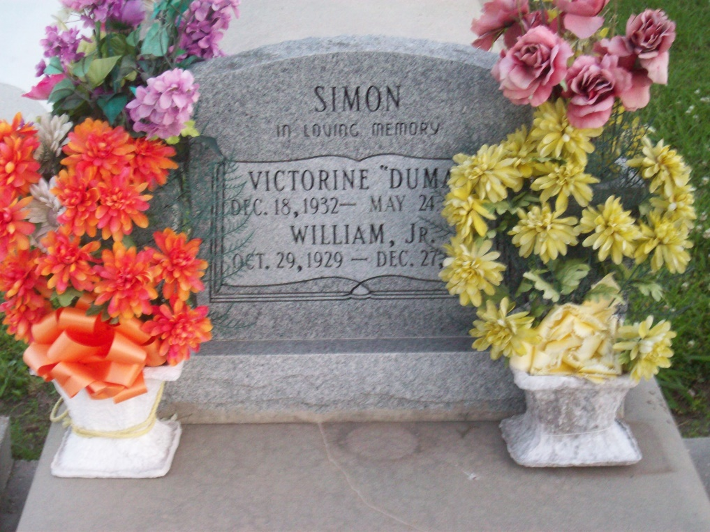

Photo by TMB

**William Or Peanut Simon, Jr., 72**

A retired employee of Vacherie Elementary School and Avondale Shipyard, he died Thursday, Dec. 27, 2001, at Thibodaux General Hospital. He was 72 and a native and resident of Vacherie. Visiting at Our Lady of Peace Catholic Church, 1328 La. 644 S., Vacherie, from 8 a.m. until Mass of Christian Burial at 11 a.m. Monday, officiated by the Rev. Tim Oubre, celebrant, and the Rev. Henry Gautreau, pastor. Interment in church cemetery. Survived by his wife, Victorine Dumas Simon, Vacherie; three daughters, Jeanelia, Beverly and Jacqueline; six sons, Martin, Melvin, Larry, George, Leo and William Simon; four sisters, Aldonas, Clothile, Velma and Ora Lee; a brother, Joe Simon; 14 grandchildren and a host of nieces, nephews, other relatives and friends. Preceded in death by parents, William and Aldonia Williams Simon; three brothers, Dennis, Ralph and Jessie Simon; and a sister, Wilborine Chopin. Williams & Southall Funeral Home, Thibodaux, in charge of arrangements.

Advocate, The (Baton Rouge, LA) - Sunday, December 30, 2001

Contributed by Jane Edson